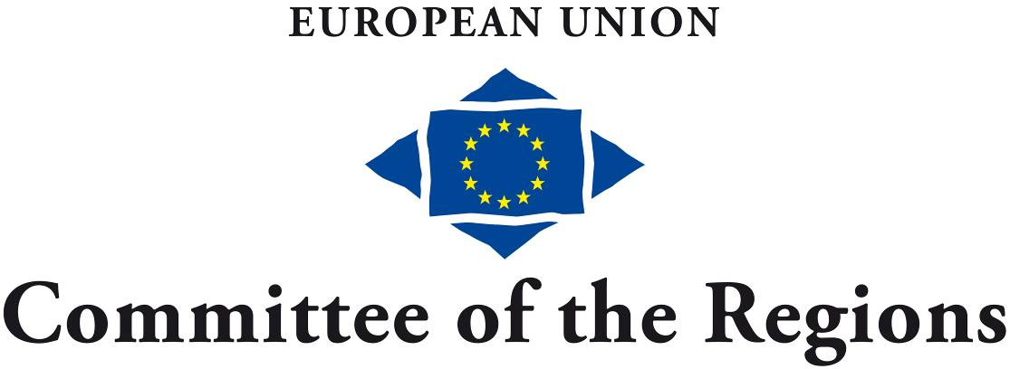
EN

Brussels, 26 June 2015

161st MEETING OF THE EUROPEAN COMMITTEE OF THE REGIONS BUREAU

– 7 JULY 2015 –

ITEM 5a

REPORT ON THE IMPACT OF COR OPINIONS

- EXECUTIVE SUMMARY -

Submitted by the secretary-general

FOR DEBATE

MEMO FOR CoR BUREAU MEMBERS

161st MEETING OF THE EUROPEAN COMMITTEE OF THE REGIONS BUREAU

– 7 July 2015 –

Item 5a

Report on the impact of CoR opinions

- Executive Summary -

The annual Impact Report of the European Committee of the Regions (CoR) is an important milestone in the political year, an opportunity to take stock of the political achievements of CoR members. 2014 was an unusual year for the European Union. Due to European Parliament elections and the establishment of a new European Commission, the legislative work carried out was limited in comparison with previous years. During this period, which also coincided with the end of its term of office, the CoR was still well able to communicate its key messages to the European Parliament and the Council and got actively involved in the hearings of the candidates for the new European Commission passing on its political messages to the members of the European Parliament and the candidates themselves.

Over the past year, the European Commission has dedicated much of its time to preparing and analysing future initiatives and legislative proposals. All pending proposals have been reviewed with a view to confirming or withdrawing some of them and thus lightening the regulatory load. Fewer referrals coming from the European Commission means that the CoR commissions more often act via own-initiative opinions or engage in other political activities involving the other EU institutions. This trend will most probably increase this year.

However, the main task assigned to the CoR by the Treaty on the Functioning of the European Union (TFEU) is to issue opinions. The CoR must continue to issue relevant contributions to the inter-institutional decision making process and to convey local and regional perspectives.

As part of this new approach to consultation, the CoR commissions will need to monitor and politically assess the activities and intentions of the European Commission. They may call on the European Commission to act where it might not otherwise intend to. This requires a more thoughtful approach to the preparation of own-initiative opinions. The new cooperation agreement with the European Parliament and a more intense dialogue with the Council will also trigger new forms of political action. Moreover, qualitative and quantitative data from the CoR's networks and platforms will be able to provide more analytical and evidence-based support. This will substantiate the political messages of CoR commission members, which are transmitted to other EU institutions via written and oral consultations.

INTRODUCTION

Under Article 60 of the Rules of Procedure, the secretary-general has to submit a report on the impact of Committee opinions at least once a year to the plenary assembly.

A total of 53 opinions with a significant impact in 2014 are included in this report. The following criteria were used to define the "impact" of opinions: specific CoR proposals incorporated into final legislation; CoR policy recommendations considered in proposed legislation or in legislative procedures; CoR positions which have made a major contribution to ongoing political debates; and references made to CoR positions in other EU documents, such as resolutions of the European Parliament.

EXECUTIVE SUMMARY

The CoR performed well in achieving political impact in 2014, thanks to targeted strategic political planning, the strong involvement of members and their political groups and national delegations, and better follow-up for CoR opinions. This executive summary highlights a sample of the CoR's successes in 2014 in some key policy areas. The complete 2014 Impact Report can be found in the annexed document.

Multiannual Financial Framework and EU Budget

In 2014 the CoR continued to contribute to the debate on the EU budget with its opinion on The execution of the EU Budget. In line with the requests expressed in this CoR opinion, the European Commission has set up an "absorption task force" which provides technical support and enables those Member States who had unused commitments from the 2007-2013 period to share best practices.

Economic and Monetary Union and European Semester

The CoR opinion on European Long-term Investment Funds had a direct impact, as the European Parliament's position on the proposal for a regulation reflects several issues raised in it, recognising the role of cities and regions as potential beneficiaries of long-term investment (see 3.1).

In relation to the European Semester and the Europe 2020 strategy, one of the CoR's major concerns was to ensure that the role of cities and regions is properly reflected in all strategic documents. In its resolution on Employment and social aspects of the Europe 2020 strategy, the European Parliament "… calls for the involvement of national parliaments and local and regional authorities in the design and implementation of National Reform Programmes, including through multilevel governance arrangements" (see 3.2).

Regional Policy

In relation to EU cohesion policy, establishing the code of conduct as a delegated act –strongly advocated by the CoR – can be deemed an important step forward. For the first time, the code will set out a clear framework for cooperation between all partners involved in the planning and management of the European Structural and Investment Funds.

As expressed in the opinion on The added value of macro-regional strategies, the European Commission's report on improving the governance of macro-regional strategies considers multilevel governance to be essential to improving these strategies' effectiveness (see 4).

Single Market and Competition

With its revised opinion on EU guidelines on state aid for rescuing and restructuring firms in difficulty, the CoR could influence the final guidelines, including the issue, extremely important for cities and regions, of raising the thresholds that determine when state aid needs to be approved by the European Commission (see 5).

Transport and Connectivity

The CoR's recommendations on the fourth railway package – which, inter alia, comprise the application of the reciprocity principle to third-country businesses that wish to take part in tenders within the Union, the clarification of the definition of competent local authorities, including those working at cross-border level, and the option for competent authorities to directly award public service contracts – made their way into the EP legislative resolutions in February 2014. In terms of the Council position, some CoR recommendations for legislative amendments were also taken on board in 2014, such as the right of appeal if the European Railway Agency fails to act within the prescribed time limits.

As far as telecommunication infrastructures are concerned, the following elements were taken on board in final legislation as requested in the CoR opinion on Guidelines for trans-European telecommunications networks: cooperation between expert groups and entities such as local and regional authorities, and the involvement of local and regional authorities in the process of exchanging information and best practices in relation to the implementation of this regulation.

The final text of the Directive on the deployment of alternative fuels infrastructure took on board a number of key policy recommendations set out in the CoR opinion on Clean power for transport, such as those regarding the extension of deadlines, the establishment of national policy frameworks in close cooperation with regional and local authorities, the fact that the interests of regional and local authorities must be taken into account in national policy frameworks, and consideration of the needs of rural and sparsely populated areas when planning national policy approaches (see 6.1).

Multilevel Governance

In relation to multilevel governance, as of January 2015 the Charter for Multilevel Governance in Europe has been signed by 179 LRAs and 21 associations or networks and received political support from major European figures. Following the adoption of a report on Multilevel governance and partnership, the principle of multilevel governance was incorporated into the legal provisions of the European Structural and Investment Funds for the first time.

Environment and Climate Change

As requested in the opinion on the Green Paper on Framing 2030 Climate and Energy Policy, which responded to consultations on EU climate and energy policies between 2020 and 2030 launched by the European Commission, the European Parliament report also included a call for closer involvement of local and regional authorities in the new climate and energy framework.

In relation to EU waste policy, the CoR was able to influence the circular economy package by means of four opinions. The legislative proposal reflects the CoR's recommendations: ending EU funding for landfill and incineration, reinforced extended producer responsibility, higher targets for plastic packaging waste and the introduction of an aspirational target of a 30% reduction in marine litter by 2020, for some types of litter found on beaches (see 9).

Agriculture and Maritime Affairs

In agricultural policy, the CAP, the CoR adopted an opinion on Information provision and promotion measures for agricultural products on the internal market and in third countries. Some CoR requests were taken on board in the final act: a reference to the geographical origin of a product; access to information provisions and promotion measures on the internal market and in third countries for wine; the involvement of Member States in the evaluation and selection of programmes; the increase of European co-financing, especially for information and promotion measures during agricultural crises, and as regards multi-programmes in third countries.

In terms of maritime spatial planning and integrated coastal management, the CoR amendments were partially taken up by the co-legislators on the following issues: the approach to be taken; the review by the Member States; and addition of "enhanced cross-border cooperation" (see 10, 11).

Europe for Citizens

The CoR stepped up its efforts to promote a decentralised EU communication policy. Its opinion on Reconnecting Europe with its citizens contributed to public debate on rebuilding citizens' trust in the European integration project and received a great deal of direct interest from the EU institutions – the European Parliament and the European Commission – and managed to influence their deliberations on the new multi-annual communications strategies (see 12.1).

Europe as a Global Actor

In response to the CoR's annual opinion on the EU enlargement strategy, the European Commission acknowledged the CoR's call for the state of local and regional self-government to be included in the annual progress reports on candidate countries, as part of the political criteria for the stability of institutions guaranteeing democracy.

_____________

