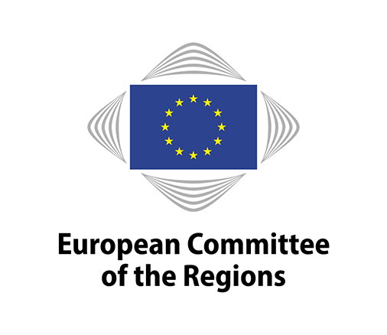
CIVEX-VII/006
7th commission meeting, 30 March 2021

DRAFT OPINION

Commission for Citizenship, Governance, Institutional and External Affairs

Strategy to strengthen the application of the EU Charter of Fundamental Rights in the EU

_____________

Rapporteur: Jean-Luc Vanraes (BE/Renew Europe)
Member of Uccle Municipal Council
_____________

This document will be discussed at the meeting of the Commission for Citizenship, Governance, Institutional and External Affairs to be held from 11 a.m. to 4.30 p.m. on Tuesday 30 March 2021. To allow time for translation, any amendments must be submitted through the online tool for tabling amendments (available on the Members' Portal: https://memportal.cor.europa.eu/) no later than 3 p.m. (Brussels time) on Wednesday 17 March. A user guide is available at https://memportal.cor.europa.eu/.

Reference document

Communication from the Commission to the European Parliament, the Council, the European Economic and Social Committee and the Committee of the Regions - Strategy to strengthen the application of the Charter of Fundamental Rights in the EU
COM(2020) 711 final
Draft opinion of the Commission for Citizenship, Governance, Institutional and External Affairs – Strategy to strengthen the application of the EU Charter of Fundamental Rights in the EU

- POLICY RECOMMENDATIONS

THE EUROPEAN COMMITTEE OF THE REGIONS

- welcomes the new Strategy to strengthen the application of the EU Charter of Fundamental Rights, as it specifically acknowledges the role of local and regional authorities (LRAs) as central stakeholders in promoting and protecting Charter rights;

- calls for continuous involvement of LRAs, a fundamental level of democratic legitimacy, in promoting Charter values and monitoring compliance with the principles associated with it;

- agrees that the EU should continue to encourage the exchange of good practice and experience between all levels of government (national, regional and local) and the development of more targeted guidance and training on the Charter;

- underlines the importance of the targeted guidance for explaining why fundamental rights are important for LRAs, partly by providing examples of how authorities can make use of the EU Charter;

- notes the important role that national and European associations of LRAs can play in this context, and is committed to step up its cooperation with them in order to raise LRAs' awareness and understanding with regard to the EU Charter;

- stresses the importance of setting up contact points, which will facilitate the flow of information on the Charter between different levels of government and can also provide guidance for LRAs on how to shape their policies in full compliance with the Charter;

- welcomes the funds allocated by the European Commission through the Rights and Values Programme to help municipalities and associations to work together on issues of common interest, enabling the exchange of good practice, and to develop networks of towns;

- acknowledges that all EU Member States need to appoint local coordinators with a clear mission statement on the implementation of the Charter, as proposed by the European Commission;

- considering the key role played by LRAs in ensuring the application of the Charter of Fundamental Rights, believes that the participation of the CoR is essential in the inter-institutional dialogue concerning the Charter;

- considers that the European Commission should systematically perform a cross-check against the application of the Charter prior to granting EU funds, using a clear and transparent procedure;

- calls for the Fundamental Rights Charter to be enacted on Europe Day (9 May) and asks its members to promote local activities explaining and stressing the paramount importance of fundamental rights and the European Charter for our democracies;

- fully supports the accession of the European Union to the European Convention on Human Rights and Fundamental Freedoms;

- believes that its achievement will constitute a major milestone in strengthening the application of the EU Charter of Fundamental Rights in the European Union and at the same time, that this will further strengthen the EU's position on trying to make human rights a core component of its external action.

- PROCEDURE

Title | Opinion on the Strategy to strengthen the application of the EU Charter of Fundamental Rights in the EU
Reference(s) | Communication from the Commission to the European Parliament, the Council, the European Economic and Social Committee and the Committee of the Regions Strategy to strengthen the application of the Charter of Fundamental Rights in the EU  COM(2020) 711 final
Legal basis | Art. 307(1) TFEU
Procedural basis | Rules 41(b)(i) and 43 of the RoP
Date of Council/EP referral/Date of Commission letter | 3 December 2020
Date of Bureau/President's decision
Commission responsible | Commission for Citizenship, Governance, Institutional and External Affairs
Rapporteur | Jean Luc Vanraes (BE/Renew Europe), member of Uccle Municipal Council
Analysis | 18 December 2020
Discussed in commission | 16 February 2021
Date adopted by commission | Scheduled for 30 March 2021
Result of the vote in commission
(majority, unanimity)
Date adopted in plenary | Scheduled for 30 June – 2 July 2021
Previous Committee opinions | Opinion on the Strategy for the effective implementation of the Charter of fundamental rights by the European Union, rapporteur: Lotta Håkansson Harju (SE/PES), adopted in 2010;  Opinion on Local and regional authorities and the multilevel protection of the rule of law and fundamental rights in the EU, rapporteur: Luc Van den Brande (BE/EPP), adopted in February 2015;  Resolution on The Rule of Law in the EU from a local and regional perspective, adopted at the 122nd CoR plenary session in March 2017;  Opinion on Strengthening the rule of law within the Union – A blueprint for action', rapporteur: Franco Iacop (IT/PES), adopted in February 2020.
Date of subsidiarity monitoring consultation | N/A

_____________

