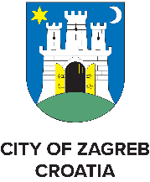
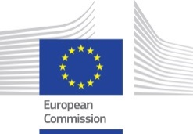
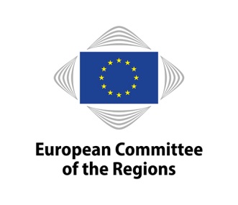

Knowledge Exchange Platform on Social Innovation

Peer-to-peer Event in Zagreb – Croatia

“Quadruple Helix approach to social innovation ‒

a key to success”

30 – 31 January 2020

30 January:
Study visits for the participants
15:00 – Meet at Hotel International (organised bus transportation)
A sightseeing tour of Zagreb with a local tourist guide is foreseen during the bus transportation.

15:30 – 16:15 Zagreb Innovation Centre (ZICER)
Founded by the City of Zagreb with the aim of improving the entrepreneurial environment and the society as a whole. It puts a special emphasis on the development of innovative high technology products through a carefully developed incubation and acceleration programmes.

16:45 – 17:45 Silent Café – a social enterprise
Hospitality service establishment of the Association of the Deaf and Hard of Hearing of the City of Zagreb, the only one of its kind in Croatia, which employs persons who are deaf or hard of hearing. It was established with the support of the City of Zagreb.

18:45 – The City Palace Dverce
Reception, dinner and networking
31 January:
Venue: Hotel International, Miramarska 24, Zagreb, Croatia
8:30 - 9:00 Registration and Coffee

Moderator: Ilaria D'Auri – EUROPEAN REGIONS RESEARCH & INNOVATION NETWORK

09:00 – 09:30 Welcome and Introduction
- Jelena Pavičić Vukičević, PhD, Deputy Mayor of the City of Zagreb, CoR member
- Martin Baričević, Mayor of the Municipality of Jasenice, president of the Croatian Union of Municipalities, Deputy CoR member
- Dubravko Bilić, mayor of Ludbreg, vice president of the Association of Cities of the Republic of Croatia
- Igor Andrović, mayor of Virovitičko – podravska county
- Marija Pletikosa, State secretary at the Ministry of Demography, Family, Youth and Social Policy

9:30 – 11:15 Social Innovation at European level (including Horizon 2020 projects)
- Philippe Martin, European Commission, DG Research and Innovation, Leader Social Innovation Matrix Team
- Risto Ravio, European Commission, DG Employment, Social Affairs and Inclusion, Job Creation Unit
- Marie Zvolska, European economic and social committee
- Catherine Naughton, president of the European Disability Forum
- Hanna Malik-Trocha, City of Warsaw, Welfare & Social Projects Department
- Eirini Kaldeli - Culture Labs – Recipes for Social Innovation (EU project under Horizon 2020)
- Tally Hatzakis, Transport innovation for vulnerable to exclusion people needs satisfaction (EU project under Horizon 2020)
11:15 – 11:45 Coffee Break

11:45 – 13:00 The importance of Social Innovation in the City of Zagreb
- Željka Kovačić, Development agency Zagreb for coordination and encouragement of regional development
- Ognjen Andrić, City of Zagreb
- Sanja Živković, Director at Co-Impact Foundation, member of European Venture Philantrophy Association (EVPA)
- Goran Denis Tomašković, “Dotted Soaps” social enterprise
- Mirjana Juriša, “Silent Café” social enterprise
- Višnja Majsec Sobota, Institute for Professional Rehabilitation and Employment of Disabled Persons, URIHO
13:00 – 13:30 Discussion with the members of the Committee of the Regions
- Jasna Gabrič, Mayor of the Municipality of Trbovlje
- Matteo Luigi Bianchi, Member of Morazzone Municipal Council
Q&A

