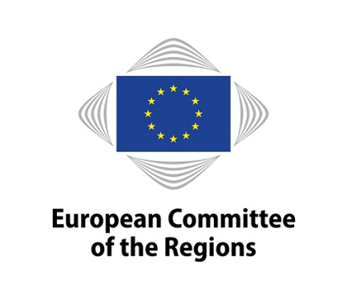
EN

Conference on

Regional Forest Innovation

Commission for Natural resources (NAT)
13 November 2019

Short Description:
While playing a major role in protecting biodiversity and providing various ecosystem services, forest also bring important economic benefits. Forest-based businesses contribute as much as 7% to economic growth. The sector employs over 3.5 million people across the European Union. It is the EU's third largest employer, just after the metal and food industries.
In rural areas, in particular, forests are a key resource for improving quality of life and job creation and thereby keeping our rural communities alive and thriving. Regional cooperation in the EU is essential to facilitate the exchange of skills and bolster competitiveness of our regions.
The first part of the conference will look into challenges and issues linked to Innovation in the Forest sector as well as tools available at the EU level, while the second part will focus on showcasing some regional best practice examples.

Venue: European Committee of the Regions, Room JDE 52, from 9h00 to 13h00

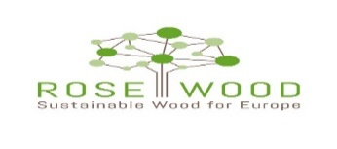
This project has received funding from the European Union’s Horizon 2020 research and innovation Programme under grant agreement No 776754
Wednesday, 13 November 2019

08:30 Registration and coffee

09:00 Welcome and introduction

- Ossi Martikainen, (FI/Renew), Chair of the NAT Commission of the European Committee of the Regions and rapporteur on the Implementation of the EU forest Strategy
- Ville Niinistö, MEP, Group of the Greens/European Free Alliance, European Parliament
- Marja Hilska-Aaltonen, Forest Counsellor, Finnish Presidency

09:30 Session 1: How to boost innovation in forest sector in EU Regions
Moderator: Marc Weinmeister (DE/EPP), Vice-President of the CoR NAT commission

- Eleonora Ganci, Unit B2, Research and Innovation, DG AGRI, European Commission, an overview of tools available at EU level;
- Sergiu Didicescu, EIP AGRI
- Bernhard Wolfslehner, Head of EFI Forest Policy Research Network, European Forest Institute
- Risto Poutiainen, Regional Mayor of North Karelia, ERIAFF, Forested Regions WG

Presentation of the best practice examples from across the European Union

- Name tbc, Hungary Innovative forest practices and tools for adaptation and mitigation to counter climate change;
- Name tbc, Valencia,
- Luc Bouvarel, A regional initiative on forest management plans for small forest owners;
- Francesca Giannetti, tbc BlueBiloba, Forest Sharing services;

11.30 Session 2: The ROSEWOOD project: Wood mobilisation and promotion of novel approaches in forest managment
- Marco Remaschi (tbc), Regional Minister for Agriculture of Tuscany, Relevance of European projects and synergies with regional policies;
- Anthony Salingre, Steinbeis-Europa-Zentrum/Steinbeis 2i, Coordinator of H2020 ROSEWOOD Project;
- Debate with the ROSEWOOD HUB Managers
12:45 Conclusions

- Marco Dus (IT/PES), CoR rapporteur on Stepping up EU action to protect and restore the world’s forests

Interpreting:

Interpreting will be provided in the following languages:

Languages in which participants may speak: 6 languages – EN, DE, FR, ES, IT, PL
Languages into which discussions will be interpreted: 4 languages – EN, FR, IT, PL

*

* *

Riccardo Castellini, Rosewood Southern Hub; Anne-Mari Väisänen, Rosewood Northern Hub; Name, Rosewood Central Hub; Ivan Ambros, Rosewood Eastern Hub

