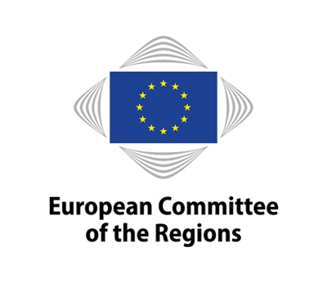
European Sea-Tech Forum #1

New green deal and new industrial policy: a new agenda for maritime industries

European Committee of the Regions - Room JDE 70 - 06 March 2020
Rue Belliard 101, Brussels

09:00 – 09:30 Registration

09:30 – 10:00 Opening Session:

Ulrica LANDERGERN (Sweden/RenewE) – Chair of CoR NAT Commission
Christophe CLERGEAU – CoR Rapporteur on "Maritime Industries"
Keynote Speech: Antoine RABAIN, expert – Challenges and opportunities of the ecological and energy transition – renewable marine energies, decarbonisation of maritime transport

10:00 – 12:00 Roundtable Session: Facing threats and shaping future: a new path for European maritime industry policy

Željko KREVZELJ, Croatian Presidency of the Council of the EU: Update on energy priorities

Proposals of European stakeholders:
- Christophe TYTGAT, Sea Europe Secretary General
- Rémy GRUET, Ocean Energy Europe, CEO
- Marian KRZAKLEWSKI, European Economic and Social Committee
- CoR members – contributions and Q&A

Position of European institutions:
- Barbara BONVISSUTO – European Commission - DG GROW
- Christos ECONOMOU – European Commission - DG MARE
- European Commission – representative of DG MOVE

12:15 – 12:30 Conclusions

12:30 – 13:00 Networking Coffee

