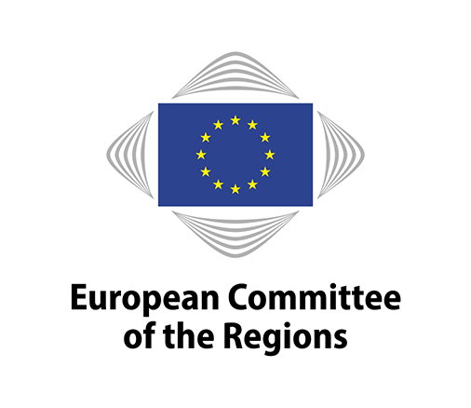
EN
Brussels, 19 May 2021

NOTICE OF MEETING

COMMISSION FOR THE ENVIRONMENT, CLIMATE CHANGE AND ENERGY (ENVE)

Important

- This meeting will be fully remote: on-site participation will NOT be possible.

- Amendments must be submitted through the online tool for tabling amendments, available on the Members' Portal at https://memportal.cor.europa.eu/. The documents for the meeting will be available on the Members' Portal.

- All times are Brussels time (CEST).

- New and improved procedure for voting on amendments and on the opinion!
Please note that you will not vote via an online form. Instead, you will vote online using a separate application, during the meeting. A step-by-step guide to voting is available on the Members' Portal (COR-2021-01962-00-00-TCD-TRA).

Meeting No | 8
Chair | Juan ESPADAS CEJAS (ES/PES)
Venue | Online (via Interactio): the links will be sent to you via email several days before the meeting
Date | Monday, 7 June 2021, 11 a.m. to 5 p.m. (Brussels time)
Amendment deadline | 25 May 2021, 3 p.m. (Brussels time)
Deadline for submitting a delegation of presence | 6 June 2021 at midnight (Brussels time)

10:00–10:30 Meeting of the political coordinators (in camera)

11:00–13:00

Draft agenda:

Adoption of the draft agenda (COR-2021-01962-00-01-CONVPOJ-TRA)

Approval of the minutes of the 7th meeting (COR-2021-01963-00-00-PV-TRA)

Statement by the Chair

Organisation of future work

For decision:

Opinions on the basis of consultations (Rule 41(a))
- Appointment of rapporteurs

Own-initiative opinions (Rule 41b) i))
- Decision to draw up an opinion
- Appointment of rapporteurs

Own-initiative opinions (Rule 41b) ii))
- Decision to request Bureau authorisation for an opinion
- Provisional appointment of rapporteurs

Decisions not to draw up an opinion (COR-2021-00179-00-00-TCD-TRA)

Ongoing work programme and decision on attributions by the president
(COR-2021-02195-00-00-TCD-TRA)

For information:

Follow-up to opinions (COR-2021-02197-00-00-TCD-REF)

Green Deal debates

Debate on the Conference on the Future of Europe (COR-2021-02576-00-00-TCD-TRA)

Statement by tbd

Debate on the European Commission's Work Programme for 2022 (COR-2021-02560-00-00-TCD-TRA)

Statement by tbd

Lunch break (1 to 2.30 p.m.). GD Helpdesk meeting (from 1 to 2 p.m.)

Debate on the path from the Climate Law towards the Fit for 55 package (COR-2021-02712-00-00-TCD-TRA)

Statement by tbd

Break (3.30 to 3.45 p.m.)

Opinions – adoption according to the procedures put in place for remote voting on amendments and opinions

Title | Guidelines for trans-European energy infrastructure
Rapporteur | Robert Sorin NEGOIȚĂ (RO/PES)
Document | COR-2021-00722-00-00-PA-TRA
Type of opinion | Mandatory, Rule 41, a) RoP
Dossier | ENVE-VII/016
Statements by | Joachim BALKE, Head of Unit, Infrastructure and Regional Cooperation (ENER.C.4), DG ENER, European Commission
Adoption planned for the plenary session | 30 June-2 July 2021
Title | Forging a climate-resilient Europe - the new EU Strategy on Adaptation to Climate Change
Rapporteur | Markku MARKKULA (FI/EPP)
Document | COR-2021-01903-00-00-PA-TRA
Type of opinion | Own-initiative opinion, Rule 41, b)(i) RoP
Dossier | ENVE-VII/017
Statements by | Elena VISNAR MALINOVSKA, Head of Unit, International and Mainstreaming and Policy Coordination – Adaptation (CLIMA.A.3), DG CLIMA, European Commission
Adoption planned for the plenary session | 30 June-2 July 2021

Opinion – Exchange of views

Title | Gender equality and climate change: towards gender mainstreaming in the European Green Deal"
Rapporteur | Kata TUTTO (HU/PES)
Document | COR-2021-02509-00-00-DT-TRA
Type of opinion | Own-initiative opinion, Rule 41, b)(ii) RoP
Dossier | ENVE-VII/018
Statements by | tbc
Adoption planned in the commission | 9-10 September 2021 in Azores (PT)
Adoption planned for the plenary session | 12-14 October 2021

Confirmation of the date of the next meeting: 9-10 September 2021 in Azores (PT) (TBC)

Any other business

Working languages: | 23 | BG/ES/CS/DA/DE/ET/EL/EN/FR/HR/IT/LV/LT/HU/MT/NL/PL/PT/RO/SK/SL/FI/SV
Interpreting:  (participants may speak in their own language) | 13 | ES/CS/DE/EL/EN/FR/IT/HU/NL/PL/RO/SK/FI
(participants may listen in) | 13 | ES/CS/DE/EL/EN/FR/IT/HU/NL/PL/RO/SK/FI

Amendments must be submitted through the online tool for tabling amendments (available on the Members' Portal at: https://memportal.cor.europa.eu/).

N.B.: The meeting will be a remote one. Members will receive the necessary information to connect to the remote-meeting platform in due time before the meeting.

This agenda is sent to all members of the ENVE commission for information. Please be aware that your participation (or delegation to participate) and entitlement to any payment or reimbursement are subject to 1) the validity of your mandate as a member of the Committee of the Regions at the moment of the meeting, and 2) the relevant CoR regulations applicable to online meetings that are in force at the moment of the meeting.

Members are asked to use the online system for the delegation of presence and voting rights in order to confirm their participation in the online meeting or to notify the secretariat of any delegation of presence to another member or alternate under Rule 5(2) of the Rules of Procedure. The online system is accessible through the Members' Portal on the CoR main website.

The Helpdesk (+32-2-546-9697; email: helpdesk@cor.europa.eu) will be happy to provide any further assistance you may need.

Disclaimer: "In accordance with CoR Bureau Decision No 15/2018, this meeting will be audio-recorded and web-streamed, and may be video recorded and photographed. The Committee may use the material thus collected for internal and external communication purposes. Personal data will be processed in compliance with Regulation (EU) 2018/1725. The Committee is not responsible for any use made of the video or audio material of this meeting by a third party, which requires the express consent of the participants in the meeting."
_____________

