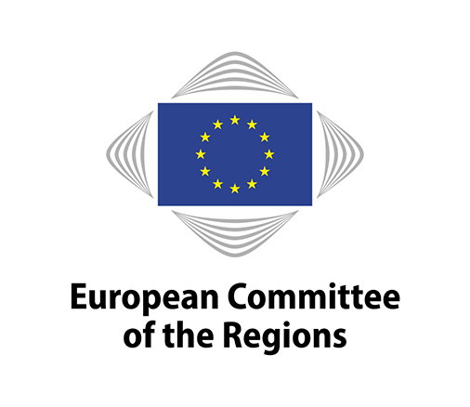
EN

Brussels, 13 November 2019

NOTICE OF MEETING

COMMISSION FOR THE ENVIRONMENT, CLIMATE CHANGE
AND ENERGY (ENVE)

Meeting No | 26
Chair | Cor LAMERS (NL/EPP)
Venue | Committee building, rue Belliard 101, 1040 Brussels (JDE52)
Date | 21/11/2019 11:00-17:30
Amendment deadline | 08/11/2019 15:00 (Brussels time)
Deadline for submitting a delegation of presence | 20/11/2019 at midnight (Brussels time)

10.30-11.00 a.m. The political coordinators' meeting will be held in camera (JDE 70).

Draft agenda:

Adoption of the draft agenda (COR-2019-03692-00-02-CONVPOJ-TRA)

Approval of the minutes of the 25th meeting (COR-2019-04415-00-00-PV-TRA)

Statement by the chair/End of mandate report

Organisation of future work

For decision:

Opinions on the basis of consultations (Rule 41(a))
- Appointment of rapporteurs

Own-initiative opinions (Rule 41b) i))
- Decision to draw up an opinion
- Appointment of rapporteurs

Own-initiative opinions (Rule 41b) ii))
- Decision to request Bureau authorisation for an opinion (COR-2019-4988-00-00-TCD-TRA)
- Provisional appointment of rapporteurs

Decisions not to draw up an opinion

Ongoing work programme and decision on attributions by the president

(COR-2019-04166-00-00-TCD-TRA)

For discussion:

Follow-up to opinions (COR-2019-04371-00-00-TCD-TRA)

Debate on The European Green Deal in partnership with local and regional authorities
Political Roundtable, with:
- Diederik SAMSOM, Head of Cabinet of Commissioner Timmermans
- Member of the ENVI Committee, European Parliament (tbc)
- Member of the ITRE Committee, European Parliament (tbc)
- Janez POTOCNIK, co-chair of the International Resource Panel of the UN
Discussion with the ENVE members

Stakeholders Roundtable, with:
- Renée BRUEL, Member of the Steering Committee, The Coalition for Energy Savings
- Piotr SZYMANSKI, Director, JRC, European Commission
- Eliot WHITTINGTON, Director, Corporate Leaders Group
- Astrid LADEFOGED, Head of Unit, DG ENV, European Commission (tbc)
Discussion with the ENVE members

1.20 p.m. The meeting will include a buffet lunch hosted jointly by the ENVE Chair and ICLEI in the JDE Atrium 5.

During the lunch break, the Transformative Action Award Ceremony – in the framework of the Basque declaration will take place, including statements by Karl-Heinz LAMBERTZ, President of the European Committee of the Regions (video message), Cor LAMERS, Chair of the Jury of the Transformative Action Award, Lasse P. N. OLSEN, Deputy Mayor, City of Aalborg and Wolfgang TEUBNER, Regional Director Europe, Managing Director ICLEI European Secretariat

Opinions – discussion and adoption

Title |  |  | Opinion on Towards sustainable neighbourhoods and small communities - Environment policy below municipal level
Rapporteur |  |  | Gaetano ARMAO (IT/EPP)
Document |  |  | COR-2019-3195-00-00-PA-TRA
Type of opinion |  |  | Own-initiative opinion, Rule 41(b)(ii) RoP
Dossier  Statement by |  |  | ENVE-VI/043  Mr BIANCHINI, DG ENVIRONMENT (tbc)  Ms PRENEEL, District Mayors of Borgerhout, Antwerp  Coordinator "Inspire the neighbourhoods" project - Brussels Environment (tbc)
Adoption planned for the plenary session |  |  | 12-13 February 2020

Preparations to the UNFCCC COP25 in Madrid

(COR-2019-04569-00-00-TCD-REF)

Statements:
- Markku MARKKULA, Vice-president of the European Committee of the Regions, Video message on the outcomes of the UN Climate Action Summit in New York
- Susan AITKEN, Leader of Glasgow City Council (tbc)
- Jacob WERKSMAN, Principal Adviser for International Aspects of EU Climate Policy, European Commission, DG Clima; EU's chief climate negotiator to the UNFCCC COP25
Followed by a discussion with the ENVE members

Any other business

Confirmation of the date of the next meeting: constitutive meeting on 13 February 2020 and the 27 February 2020 in Brussels (tbc) pending approval Bureau on 3rd December

Working languages: | 23 | BG/CS/DA/DE/ET/EL/EN/ES/FR/HR/IT/LV/LT/HU/MT/NL/PL/PT/RO/SK/SL/FI/SV
Interpreting:  (participants may speak in their own language) | 19 | FR-DE-EN-IT-ES-NL-PT-EL-DA-SV-CS-ET-LT-PL-RO-HR (tbc)
(participants may listen in) | 13 | FR-DE-EN-IT-ES-NL-EL-SV-CS-ET-PL-HR (tbc)

Amendments must be submitted through the online tool for tabling amendments (available on the Members' Portal at: https://memportal.cor.europa.eu/).

N.B.: Only members of this commission and alternates delegated to attend the meeting will be entitled to travel and subsistence payments.

Members are asked to use the online system for delegation of presence and voting rights in order to confirm their attendance at the meeting or to notify the secretariat of any delegation of presence to another member or alternate under Rule 5(2) of the Rules of Procedure. The online system is accessible through the Members' Portal on the CoR main website.

This agenda is sent to all members of the ENVE Commission for information. Please be aware that your participation (or delegation to participate) and entitlement to any payment or reimbursement are subject to the validity of your mandate as member of the Committee of the Regions at the moment of the meeting.

The Helpdesk (+32-2-546-9697; email: helpdesk@cor.europa.eu) will be happy to provide any further assistance you may need.
_____________

