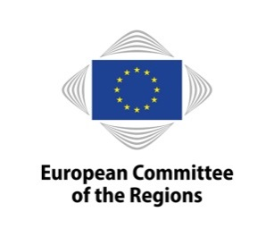 |  | 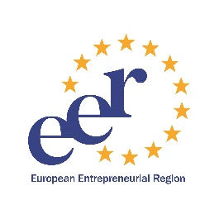
European Entrepreneurial Region 2021
Entrepreneurship for a green & sustainable future
Info Day
15 January 2020, 10:00-12:00
European Committee of the Regions, Jacques Delors Building – Rue Belliard 99-101, B-1040 Brussels
Room JDE 52 – Map: http://europa.eu/!dt37QX

AGENDA

10:00-10:10 Welcome and introduction
- Petr Blizkovsky, Secretary General of the European Committee of the Regions
- Bert Kuby, European Committee of the Regions, Head of Unit, ECON commission
10:10-10:45 Success secrets of the EER winners
Moderated by Bert Kuby
- Cristina Fanjul, Director of the Centro Europeo de Empresas e Innovación (CEEI) Asturias (EER 2019)
- Ulrike Firniss, Director for EU affairs, Business Region Gothenburg (EER 2020)

10:45-11:00 Coffee break

11:00-11:10 EER 2021 application process at glance
- Piotr Zajaczkowski, European Committee of the Regions, Policy Officer, ECON commission
  - 11:10-11:40 Insights from the EER jury
Moderated by Bert Kuby
- Katarzyna Balucka-Debska, European Commission, DG GROW, Unit for SME policy, SME envoys and relations with EASME
- Erdmuthe Klaer, European Network of Cities and Regions for the Social Economy (REVES)

11:40-11:45 Wrap-up and closing
- Bert Kuby, European Committee of the Regions, Head of Unit, ECON commission

11:45-12:15 Bilateral meetings (on request)

Watch the meeting on-line:
Registration and information:
Contact: eer-cdr@cor.europa.eu

