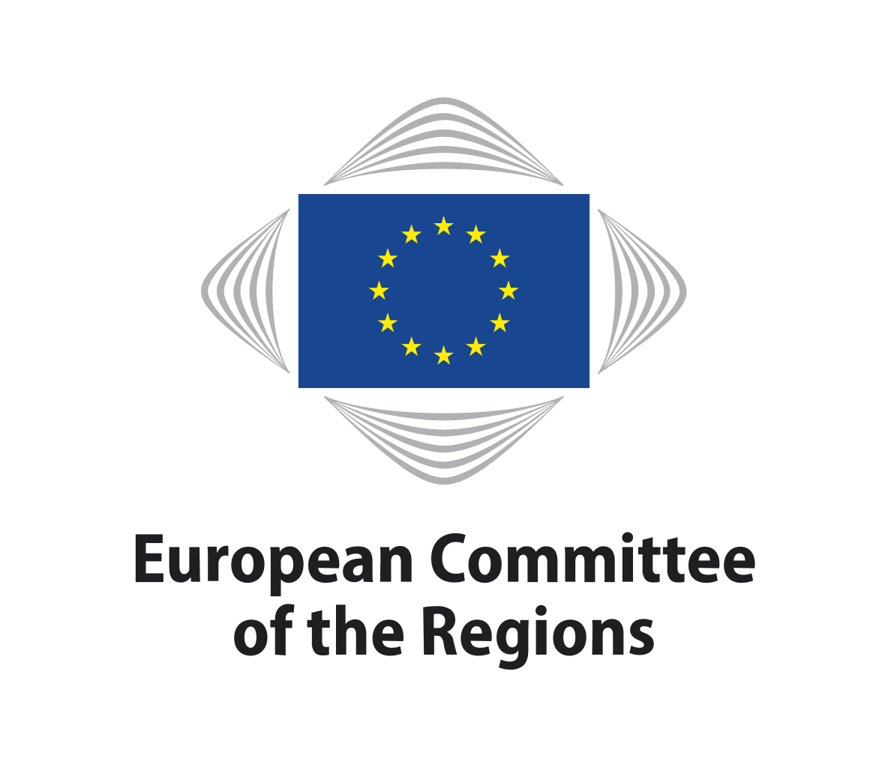

Brussels
June 2020

ECON
Commission

Summary of replies to the consultation
For the CoR opinion on A new industrial strategy for
Europe
Background

Europe has always been the home of industry. Throughout its history, it has proven its ability to lead change. Today, industry in Europe is faced with a need for a transition to sustainability and digitalisation, which increasingly have an impact on all policy areas. The communication on A new industrial strategy for Europe presented by the European Commission on 10 March 2020 addresses these challenges. The strategy aims to drive Europe's competitiveness and its strategic autonomy at a time of geopolitical instability and increasing global competition. The communication sets out to deliver on three key priorities: firstly, maintaining European industry's global competitiveness and a level playing field at home and globally; secondly, making Europe climate-neutral by 2050; and thirdly, shaping Europe's digital future. The strategy examines the key drivers of Europe's industrial transformation and proposes a comprehensive set of future actions.

Although it recognises the relevance of the local and regional authorities, the communication does not give them the importance they deserve. This was described in the CoR opinion on A Place-based Approach (adopted on 26-27 June 2019, rapporteur: Jeanette Baljeu (NL/RE)), where the CoR highlights the important role of the local and regional level in the industrial strategy and their vital role in achieving a place-based approach.

Furthermore, the strategy was published before it became clear that the COVID-19 pandemic would have such adverse effects on industry as a whole; therefore, it does not mention any of the potential impact of the crisis and, as such, it might need to be adapted/revised.

As the regions play an important role in attracting and promoting industry, the European Committee of the Regions (CoR) decided to issue an opinion on this. The Rapporteur is again Jeannette Baljeu who wanted to explore several issues in the preparation of her opinion. That is why this written stakeholder consultation was launched.

Participants

The consultation was published on the CoR website on 27 April 2020. The CoR has received 23 replies: 12 from local and regional authorities, 4 from European associations, 4 from national associations, 1 from a think tank, 1 from a consultant and 1 from a citizen.

Questions asked

- What should be the focus of the development of European industrial ecosystems, including in the light of the current COVID-19 situation?
- In your opinion, should the EC adapt competition rules and the State aid framework to new technological and global market development? If so, could you give us an example?
- How could the position of Local and Regional Authorities (LRAs) be strengthened through the new Industrial Strategy? What could the role of members of the CoR be in this?
- What is needed in your opinion to ensure fair competition globally and within the EU internal market?
- What role should LRAs play in the Pact of Skills in order to ensure an inclusive digital transition of Industry?
- Do you think the European Commission sets the right priorities? What should be emphasised more? What is missing?

1. What should be the focus of the development of European industrial ecosystems, including in the light of the current COVID-19 situation?

Participants thought that in principle the European Commission has set the right priorities and that the new European industrial strategy with its focus both on green and digital transition is strategically important. The answers to this question overlap to a certain extent with those to question 6.

The following comments were made:
- A coordinated response is necessary for rebooting economic growth (after the confinement measures to stop the spread of COVID-19) and for climate change. This entails in particular cross-border cooperation. Specialisation hubs should be established.
- Local production ecosystems should be established wherein companies in the same area/region work together. This would diminish climate impact and boost regional competitiveness.
- The new industrial strategy for Europe should have a clear focus on local authorities, taking into account their strategic role in supporting local industry and SMEs. It should support the recovery of the local economy and local labour market from the impact of the COVID-19 crisis as well as ensuring the transition towards a digital, green and inclusive economy.
- A dialogue with cities and regions should be an essential component of the development of a European industrial ecosystem. A place-based approach building on the potential of business and innovation ecosystems to drive industrial modernisation and develop territorial strategies for innovation at the LRA level would be necessary. More attention and support are needed to build effective regional innovation ecosystems that develop effective smart specialisation strategies.
- Europe should incentivise the relocation of production capacities in crucial areas such as health security. However, pharmaceuticals should be dealt with separately from the industrial strategy.
- The European Commission's leadership approach for making Europe the first climate-neutral continent should be enhanced, especially in times of a lack of global leadership on climate and the coronavirus.
- A special focus should be put on the circular economy. According to one comment, the economic recovery plan must be fully integrated into the dynamics of the European Green Deal.
- A revised new industrial strategy must build on resilience to withstand, absorb or overcome internal or external economic shocks. This involves strengthening the internal market, examining supply chains, and putting in place actions and policies that enhance resilience.
- In order to institutionalise the involvement of citizens and companies across the EU, the role of the regions and cities must be strengthened as key building blocks of the post-COVID-19 recovery. For a re-industrialisation strategy (with new societal, economic and work opportunities), the role of LRAs in supporting sustainable smart specialisation strategies that contribute to the regional and European priorities, and promoting partnerships that scale-up their efforts in European value chains must be recognised.
- The need for investments/co-investments was stressed. This applies to investment in new technologies, in the digital economy and in education in terms of links with business.
- Industrial cohesion should be favoured and sectors highly impacted by the COVID crisis like tourism, culture and transport should be supported.
- The COVID crisis showed the need to invest in human capital, R&D and innovation in the health sector and to improve and update workers' skills and the development of new IT systems, app software and digital tools allowing workers to work from home.
- One contributor requested safeguards against a flood of steel imports after the end of the lockdown.
- One contributor warned that priorities should be revised with caution. There should not be a place for the rise of national protectionism inside Europe. Focus should be on sustainable growth and green production.

2. In your opinion, should the EC adapt competition rules and the State aid framework to new technological and global market development? If so, could you give us an example?

State aid rules have to support competition within the EU. However, as a result of technological development and globalisation, European companies compete with companies outside Europe that operate under legal systems allowing greater room for manoeuvre in terms of competition law and benefit from more public financial aid. Governments are already injecting serious resources to rebuild the economy following the outbreak of the COVID-19 pandemic.

The following comments were made:
- The EU has to support Member States and companies to face this global competition, including by further strengthening the single market and by fighting unfair practices. Thus, the European Commission has to reconcile the objective of ensuring competition within its borders, protecting SMEs in particular, with that of making its businesses competitive beyond its borders. This means adapting legislation to the new market in compliance with certain constraints and conditions, such as the rules on mergers, to allow for the creation of strong European companies that can engage with non-European companies that are just as strong but are often "freer" in the way they are organised.
- The state aid framework should be reassessed to further stimulate industry-led innovation, especially concerning pilot and demonstration projects.
- State aid should be conditional on investing money in protecting and creating sustainable, resilient jobs.
- Competition rules need to be adapted to encourage sustainable investment. For example, a higher ceiling for green investment, taking into account that it is long term, was discussed. One contributor wanted to introduce a stricter environmental conditionality on granting state aid for compensating indirect costs of ETS to further incentivise decarbonisation of electricity consumption by energy-intensive sectors and fossil fuel phase out.
- Competition rules should also better address mid-sized enterprises.
- State aid guidelines should be made more flexible and the de-minimis support for agriculture and fisheries should be increased in addition to greater EFSI funds.
- Rules should be conducive to investors, innovators and authorities.

3. How could the position of Local and Regional Authorities (LRAs) be strengthened through the new Industrial Strategy? What could the role of members of the CoR be in this?

Contributors thought that the industrial strategy did not reflect the crucial role of LRAs in sustaining local economies and in implementing the industrial strategy. However, it only indicated a limited role for LRAs and a place-based approach.
They provided the following comments:
- Regions have a key role to play in the creation of ecosystems conducive to the economic development of their territories. Strong territorial ecosystems are a key component of competitive European industrial value chains.
- The new industrial strategy should fully involve regions, their representatives as well as their smart specialisation strategies to provide a top-down/bottom-up approach that can involve a wide range of stakeholders and ensure efficiency in multi-level governance. The strategy should in no way impose the narrow specialisations of Member States or regions to meet the needs of the common market. It should ensure autonomy for Member States and regions in determining development directions for the industry.
- LRAs could play an important role, especially in the design of sustainable and green public procurement and the transition to sustainable industry and green buildings. Local and regional capacities in managing the industrial strategy and specifically smart specialisation that enables interregional collaboration through value should be improved. As regions differ, there cannot be any one size fits all solution. This means that each LRA needs to build capacity at the regional level to develop revised smart specialisation strategies.
- A specific place-based approach is also the right thing to do. The regional and local level should be involved in the development of the industrial strategy. Factors such as the type of business activity undertaken, smart specialisations identified, as well as access to suitably qualified staff are regionally determined. But no one size fits all solution is possible here either.
- Creation of an EU cluster policy should be a central part of any EU industrial policy fit for purpose to strengthen the development of European world-class clusters connecting regional clusters, networks and ecosystems
- The COVID-19 crisis has shown how important a role in the rapid response to the difficult pandemic situation is played by the regions that first took action against COVID-19. Therefore, regions should be more involved in developing similar strategic documents. It has demonstrated the importance of multi-level cooperation, mainly at the regional level and the national level.
- Local, regional and national networks for the purpose of collaboration and uniformity should be established. Innovation and circular/sustainable initiatives should be supported financially and by appropriate legislation.
- Furthermore, the role of LRAs should be strengthened with regard to policies for SMEs which are of direct benefit to their areas of provenance.
- The CoR should actively promote the need for a strong regional focus in any future recovery plan as its members represent the regions and know their needs and challenges best. They are able to correctly determine its opportunities and threats, as well as strengths and weaknesses. They should be formally associated with local institutions when designing local development initiatives. The CoR should make sure that civil society and all local stakeholders can contribute to finding solutions and deciding how they could be funded.
- The CoR could propose a definition of ecosystems: industrial ecosystems, territorial ecosystems of innovation as different Commission DGs are using this concept without concrete examples.
- The CoR could designate a representative in the industrial forum to be the link between the LRAs and the Commission.

4. What is needed in your opinion to ensure fair competition globally and within the EU internal market?

A level playing field in global trade, meaning that all countries and companies compete on an equal footing to offer consumers everywhere the widest possible choice and the best value for money. Contributions were concentrated around the following issues:
- Respondents thought that the rules-based multilateral trading system, embodied in the World Trade Organization (WTO), shows gaps in its rulebook and unfinished business continues to undermine progress towards a freer, fairer, and open trading system. These gaps in areas such as agriculture, fossil fuel, services or export restrictions of raw material should be filled. All WTO countries should abide by the WTO rules.
- The EU industrial strategy should make developing networks of state-of-the-art pilot infrastructures, demonstrators, and shared facilities with open access to SMEs in Europe a clear priority. In their view, this is crucial to enable market uptake of new innovative technologies and foster EU competitiveness and modernisation of industry. Interregional cooperation could play a key role in this regard.
- In order to develop smart industries, place-based innovation and experimentation should be encouraged.
- In order to ensure fair competition (within the EU and globally), it is important to develop and promote harmonised and comparable social and environmental (including the internalisation of external costs) standards. Market surveillance should be strengthened. More should also be done for online sales and preventing the sale of non-compliant or dangerous products online from shops outside the EU but shipped to the EU.
- Free Trade agreements should include Dispute Settlement Sample Clauses for facilitating the resolution of technical barriers to trade and/or more generic barriers to trade.
- A strong single market that brings down barriers and cuts red tape would be helpful. No "gold plating" of EU legislation should take place in EU Member States and regions.
- In order to compete with unfair competition, a level playing field both in terms of state aid, taxation and training as well as recognising that different situations warrant different solutions should be created. Only companies which for historical, geographical and cultural reasons are disadvantaged compared to others should receive favourable treatment.
- A framework that provides political and policy direction that investors, innovators and industries need should be established.
- Initiatives such as the EU Cities for Fair and Ethical Trade Award have been helpful in ensuring that local public administrations can contribute to fair competition globally and should be continued.

5. What role should LRAs play in the Pact of Skills in order to ensure an inclusive digital transition of Industry?

Industry needs to adapt to new social, ecological and financial conditions and consequently it needs to adopt new technologies and solutions. The digital transformation of the economy is one of the most important priorities in the age of the epidemic and after it, when many enterprises will probably reduce employment. Respondents thought that it was necessary to provide the necessary skills for the digital transformation.
Many respondents thought that LRAs could play an important role in ensuring the availability of skills to support the industrial competitiveness and transition. Regions are best positioned to facilitate the collaboration between industry, (applied) research, and education for the development of new training schemes and ensuring fair access to the new technological and innovation skills demanded by industry. Pre-skilling and up-skilling the labour force can also help deal with skills gaps and accelerate the digital and green transition.
LRAs could be network partners (also with private actors). They could offer place-based opportunities for the implementation of the Pact of Skills for the local/regional workforce and promote digital transition of industry through field labs, pilot programmes and networks. For example, in North Holland, this is already done by setting up a smart industry hub together with private and local stakeholders. Furthermore, it should be ensured that programmes with similar initiatives collaborate with each other.
It was pointed out that, in agreement with universities and educational institutions, curricula should offer skills acquisition courses targeting not only students but also workers, and support should be provided for economic activities specialising in digitalisation so that they can assist other businesses. In particular, local authorities could also directly support private individuals by opening dedicated information points.
Moreover, LRAs could share their challenges and best practices in dealing with skills and industries, how to establish good relationships with industry, universities and other players.

6. Do you think the European Commission sets the right priorities? What should be emphasised more? What is missing?

Many respondents believed that in principle the European Commission set the right priorities. Focusing on the environment and on digitalisation is the right call for the future, as they will both play an important role in the coming decades. The following comments were made:

- The importance of investments was highlighted: The industrial strategy that supports this new growth strategy should emphasise the mechanisms for committing public and private actors to co-invest. The multi-level governance of the recovery strategy requires a more orchestrated approach to align investments on priority areas. Present proposals to set-up alliances for large projects are not enough. What is missing is an ambition to call upon the broader population to participate in rebuilding a European industry to make our economy more competitive, sustainable, and resilient. The Climate Pact is a first step.
- The role of cities and regions should be recognised, for example through strategic use of public procurement, in driving the digital and green transition. Regional stakeholders should be part of designing the strategy and not only mentioned to finance the implementation of the strategy. As all regions are different, a place-based approach building on the potential of business and innovation ecosystems at the LRA level would be crucial. Thus, more attention and support are needed to build effective regional innovation ecosystems which develop effective smart specialisation strategies based on well-performing EDPs which specifically target research institutions and universities (especially those supporting regional industries and skills), SMEs and cluster organisations and civil society. To develop this quadruple helix, place-based leadership must be provided by the LRAs.
- There is a lack of information on how this new strategy will be governed and implemented. The Communication does not answer the question of who will be responsible for implementing these strategies and at what level. Any industrial strategy needs to be implemented by multi-level governance where each level is given clear responsibilities and resources for implementation.
- Monitoring and evaluation should be carried out at three levels: EU, Member States and regions and reported back annually. At the EU level this can be done in the European Semester and linked to National Reform Plans at Member State level. Regions should monitor and evaluate their smart specialisation strategies annually not only as an audit function but also as a learning tool supporting a more diagnostic monitoring, checking on progress and facilitating problem solving. Member States should be encouraged to incorporate tangible elements of their smart specialisation strategies' progress when reporting to the Commission in the context of the European Semester.
- One comment stressed the importance of Europe's industrial independence in the production of key strategic products and strengthening and accelerating the digitalisation and development of 5G networks, while ensuring their funding at European level.
- The new industrial strategy should acknowledge the essential role of the sustainable bio-based industries and promote the use of environmentally friendly circular products and solutions. A focus should be put on designing specific circular bioeconomy (CBE) strategies focused on the production and utilisation of biological resources to generate high-value bio-based products as regions represent the most appropriate level for this.
- One comment believed that the European Commission missed a chance to carve in stone that climate neutrality is this sector's duty as much as anyone else's and industry should not rely on other sectors such as agriculture or forestry to offset what today are considered its hardest-to-abate emissions
- Communication about plans, policies and regulations are sometimes unclear for LRAs to understand and therefore adopt. The European Commission should ensure a supportive top-down as well as bottom-up approach when it wishes to implement them.
- Education and research are mentioned but they should be emphasised more. Both education and research are realised somewhere, which is in regions and cities of Europe. There should also be a priority to encourage education and research at local level so that public institutions and private companies could network more actively.
- The agro-food industry should be considered a key ecosystem of the EU. The pharmaceutical industry is also crucial.
- One contributor regretted that the new industrial strategy for Europe contained too many generalisations. The relationship between industrial policy goals and cohesion policy goals is not further defined. There is therefore a risk of overlapping policies and goals. In addition, it should be noted that entrepreneurs and industry cannot be controlled, nor should a top-down vision of development be imposed, it should be a bottom-up process resulting from the conditions of the region. Industrial policy should promote new opportunities and present visions of modern development instead of setting specific goals to be achieved.

COM(2020) 102 final, https://ec.europa.eu/info/files/commission-communication-new-industrial-strategy-europe_en
https://cor.europa.eu/en/events/Pages/ECON-new-industrial-strategy-for-Europe.aspx

