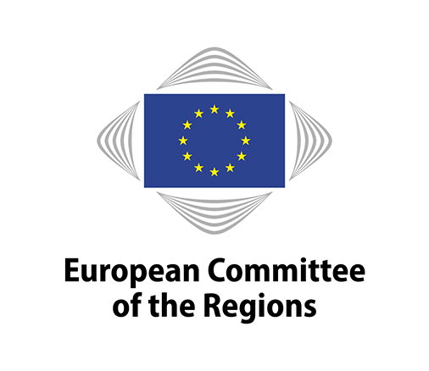
EN
Brussels, 11 June 2021

NOTICE OF MEETING

7th Mandate – COTER commission

In light of the current COVID-19 situation, the meeting will be held by video conference only.

VOTING ON AMENDMENTS AND OPINIONS WILL TAKE PLACE REMOTELY DURING THE MEETING.

Members will have access to a PRACTICAL GUIDE (COR-2021-01645-00-02-TCD-TRA) on how to connect to the remote meeting platform and how to vote on amendments and opinions in due time before the meeting. All documents for the meeting, including documents relating to voting, will be available exclusively on the Members' Portal. Please note that the delegation for the meeting will also cover the votes.

Meeting No | 9
Chair | Isabelle BOUDINEAU (FR/PES)
Venue | Online meeting (via Interactio)
Date | 22/06/2021 11:00 – 16:30
Amendment deadline | 09/06/2021 15:00 (Brussels time)
Deadline for submitting  a delegation of presence | 21/06/2021 at midnight (Brussels time)

10:00 – 10:30: The political coordinators' meeting will be held in camera

- New and improved procedure for voting on amendments and on the opinion Since April 2021

Please note that, as during the COTER meeting of 23 April, you will no longer vote via an online form. Instead, you will vote online, during the meeting. A step-by-step guide to voting is available on the Members' Portal (COR-2021-01645-00-02-TCD-TRA)
Draft agenda:

11:00 – 13:00

Adoption of the draft agenda
COR-2021-02469-00-03-CONVPOJ-TRA

Approval of the minutes of the 8th meeting
COR-2021-02465-00-00-PV-TRA

Statement by the chair
COR-2021-02466-00-00-LET-TRA

Organisation of future work

For decision:

Opinions on the basis of consultations (Rule 41(a)) – Appointment of rapporteurs

Own-initiative opinions (Rule 41b) i))
- Decision to draw up an opinion
- Appointment of rapporteurs

Own-initiative opinions (Rule 41b) ii))
- Decision to request Bureau authorisation for an opinion
- Provisional appointment of rapporteurs

Decisions not to draw up an opinion

Ongoing work programme and decision on attributions by the president
COR-2021-00486-00-04-TCD-TRA

For discussion:

Follow-up to opinions
COR-2021-00494-00-03-TCD-REF

Opinions - First discussion and adoption

 | Title | Effectively engaging local and regional authorities in the preparation of the Partnership Agreements and Operational Programmes for the 2021-2027 period
 | Rapporteur | Juraj Droba (SK/ECR)
 | Commission document | N/A
 | Document | COR-2021-02505-00-00-PA-TRA
 | Type of opinion | Own-initiative – Rule 41 (b) (i)
 | Dossier | COTER-VII/012
 | Statement by | Witold WILLAK (Deputy Head of Unit Coordination of programmes, DG REGIO, European Commission)
 | Adoption (planned) in the commission | 22 June 2021
 | Adoption planned in the plenary session | 11–13 October 2021

Presentation of the State of Play of the European Week of Cities and Regions by Ian BARBER, Director for Communication at the CoR, followed by a debate with members

13:00 – 14:30: Lunch break

14:30 – 16:30

Opinions – Exchange of Views

 | Title | The gender dimension of structural and cohesion funds 2021-2027, with a focus on the preparation of the operational programmes
 | Rapporteur | Donatella PORZI (IT/PES)
 | Commission document | N/A
 | Document | COR-2021-02503-00-00-DT-TRA
 | Type of opinion | Own-initiative – Rule 41 (b) (ii)
 | Dossier | COTER-VII/014
 | Statement by | A representative of the European Commission (tbc)
 | Adoption (planned) in the commission | 28 October 2021
 | Adoption planned in the plenary session | 1-3 December 2021

Update on the European Year of Rail 2021

Statements by:

Matthew BALDWIN, Deputy Director-General at DG MOVE, European Commission,

João JESUS CAETANO, Counsellor at the Permanent Representation of Portugal to the European Union,

Conor GILLIGAN, Trainee at the COTER commission of the CoR ("The EYR and the Y-factor project").

Followed by a discussion with members.

COR-2021-01972-00-02-TCD-TRA

Cooperation with OECD
Presentation by Lamia Kamal-Chaoui, Director of the OECD Centre for Entrepreneurship, SMEs, Regions and Cities, and discussion with members.
COR-2021-02962-00-01-TCD-TRA

Any other business

Confirmation of the date of the next meeting:
28 and 29 October 2021 (external meeting) – (tbc)

End of meeting

Working languages: | 23 | BG/ES/CS/DA/DE/ET/EL/EN/FR/HR/IT/LV/LT/HU/MT/NL/PL/PT/RO/SK/SL/FI/SV
Interpreting:  (participants may speak in their own language) | 13 | BG/ES/CS/DE/EL/EN/FR/IT/NL/PL/PT/RO/SL
(participants may listen in) | 13 | BG/ES/CS/DE/EL/EN/FR/IT/NL/PL/PT/RO/SL

Amendments must be submitted through the online tool for tabling amendments (available on the Members' Portal at: https://memportal.cor.europa.eu/).

N.B.: | This agenda is sent to all members of the COTER commission for information. Please be aware that your participation (or delegation to participate) and entitlement to any payment or reimbursement are subject to 1) the validity of your mandate as member of the Committee of the Regions at the moment of the meeting, and 2) the relevant CoR regulations applicable to online meetings that are in force at the moment of the meeting.  Members are asked to use the online system for delegation of presence and voting rights in order to confirm their attendance at the meeting or to notify the secretariat of any delegation of presence to another member or alternate under Rule 5(2) of the Rules of Procedure. The online system is accessible through the Members' Portal on the CoR main website.  The Helpdesk (+32-2-546-9697) email: helpdesk@cor.europa.eu will be happy to provide any further assistance you may need.  Disclaimer. In accordance with CoR Bureau Decision No 15/2018, this meeting may be audio-recorded and webstreamed. The Committee may use the material thus collected for internal and external communication purposes. Personal data will be processed in compliance with Regulation (EU) 1825/2018. The Committee is not responsible for any use made of the video or audio material of this meeting by a third party, which requires the express consent of the participants in the meeting.
_____________

In accordance with the Bureau Regulation laying down instructions for the organisation of the plenary assembly, bureau and commission meetings of the European Committee of the Regions during the COVID-19 pandemic, and the Regulation 14/2020 on the payment of a flat-rate remote meeting allowance for members and duly mandated alternates of the European Committee of the Regions, as adopted at the Bureau meeting of 9 October 2020.

