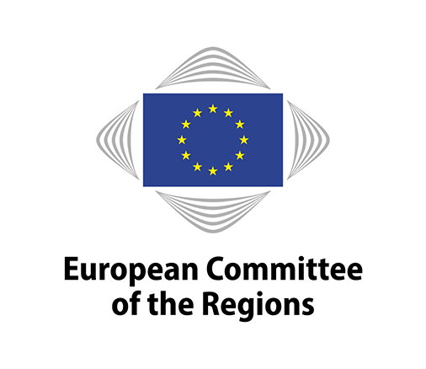
COTER-VI/053

22nd Commission meeting, 26 March 2019
EN

WORKING DOCUMENT

Commission for Territorial Cohesion Policy and EU Budget

Better Communication for Cohesion Policy

_____________

Rapporteur: Adrian Ovidiu Teban (RO/EPP)
Mayor of Cugir
_____________

This document will be discussed at the meeting of the Commission for Territorial Cohesion Policy and EU Budget to be held from 10 a.m. to 1.30 p.m. on Tuesday 26 March 2019.

Reference document

NA

Working document of the Commission for Territorial Cohesion Policy and EU Budget – Better Communication for Cohesion Policy

There is little awareness of EU regional support and its impact is poorly perceived across Europe.

Only one third of European citizens have heard of EU co-financed projects in the area in which they live, according to the last poll in the 2017 Eurobarometer. Almost 80% of citizens, however, believe that these projects on the development of cities or regions have been positive. Yet only half of respondents have heard of development funds, including the Cohesion Fund.

The majority of funding available under the cohesion policy is directed towards less developed regions (GDP lower than 75% of the EU average) and "transition regions" (GDP between 75% and 90% of the EU average).Individual Member States and their regions are usually the main recipients of co-financing for development projects. However, the EU is trying to promote horizontal cross-border cooperation in macro-regions such as the Danube or the Alpine region, in an effort to promote a shared approach to drive growth in these regions.

More macro-regions (such as a presumptive Carpathian region) in less developed areas of the EU can increase the absorption of regional funds, enhance cohesion policy, bridge the developmental gap and bring EU cohesion policy closer to citizens.

According to the same Eurobarometer, European cohesion policies are still poorly communicated and information sources tend to be undiversified. Television remains the most common source of information about EU co-financed projects, for more than half of EU citizens. In particular, for 26% of EU citizens, television is the first source of information about EU cohesion policy.

The highest perceived priority is to invest in regions with high unemployment. EU regional policy investments should focus on education, health and social infrastructures, which are regarded as the most important areas for investment.

Multilevel governance should be followed by better communication. Over 30% of European citizens say that decisions about EU regional policy projects should be taken at regional level, whereas almost one in five think that these decisions should be taken at European level.

Therefore, communication of cohesion policy should focused on framing public information from a regional perspective.

A European public sphere: Awareness relating to cohesion policy

Qualitative research has revealed that the link between allocation of funds and awareness is stronger for people with higher levels of education and for people in their fifties.

This finding indicated that adequate communication processes and education are linked to adequate fund allocation and awareness of EU policies. Spending more on communicating cohesion policy will increase citizens’ awareness of the importance of the European Union.

However, not only economic factors produce awareness. Different strands of analysis detect groups of citizens whose awareness of EU (cohesion) policies seems to be connected to political and identification processes. As regards political involvement, awareness is more likely as the number of citizens having voted in European elections increases.

Also, besides political involvement, when identification with the European Union and with a common European history and culture is high, citizens are more aware of European (cohesion) policies. However, the role of education, welfare and age is important.

Communication of cohesion policy should be connected with campaigns aiming at political involvement at EU level. Voting in EU elections is likely to be a prerequisite for awareness and for keeping informed on European policies.

Personal benefit deriving from cohesion policy

Perceived personal benefit mixes elements of awareness and appreciation. The effect of both the general amount of EU funds pro capita and expenditure specifically allocated to communication initiatives positively correlate with a higher probability of perceived benefit for the European citizen. This is rather intuitive, as the underlying idea follows, that more funds should lead to more financed projects and more communication to knowledge and eventually the perceived benefit of the projects.

As far as European identity and political participation are concerned, they are positively and significantly associated with the probability of assuming a perceived personal benefit from EU-financed projects.

The value of mobility is positively associated with perceived benefit; however the historical-cultural element is perceived as being potentially more characteristic of individual Eurosceptic profiles.

This latter finding might open new lines of interpretation such as pointing to a perceived benefit deriving from the valorisation of the cultural heritage of regions.

Appreciation of a country's membership of the EU

The economic effect of investments seems to have some impact on citizens’ appreciation of EU membership. More specifically, allocation of funds is positively associated with higher appreciation of EU membership.

Citizens' appreciation increases as expenditure on communication of the past programming period increases. However, this effect is weak and not significant. Communication expenditure for the current programming period seems to have a negative effect on appreciation.

This situation calls for an assessment of changes in the design and administration of communication strategies in the move from the 2007-2013 programming period to 2014-2020. This has to be taken into account for the coming programming period.

The more citizens identify with Europe, the more they appreciate EU policies. Specifically, identification based on a common flag and passport, a common history and culture, a common currency and the right to work and live in any European country, correlates with an increase of appreciation.

Main lines for improved communication

Citizens' awareness and perceived effectiveness of cohesion policy are determined by media exposure and communication of EU funding. The focus should fall on regional and local news, as they are generally more positive towards the EU than national news.

Significant territorial differences in attitudes to and identification with the EU between and within countries means that both the use of EU funding and its communication need to be regionally differentiated.

Communication strategies are improving but are failing to rise to the challenge. There should be a requirement for a focus on citizens and their daily lives, on clarity in presenting EU funding, sophistication of methods, effective use of both traditional and social media and local differentiation.

The role of communication in programming and implementation should be upgraded to connect more directly with citizens and increase their appreciation of the EU.

The following questions will guide the content of the opinion:

Question 1 – Are the communication activities co-funded by cohesion policy supposed to be framed at regional and local level?

Question 2 – Is political involvement, including voting in the European elections, a prerequisite for awareness of cohesion policy?

Question 3 – Do regional cultural heritage and local conditions influence citizens' perception of cohesion policy?

Question 4 – What has been the impact of the current seven action communication campaigns implemented by the European Commission?

Question 5 - What opportunities are opened up by the introduction of new measures on communication, visibility and transparency within the future cohesion policy beyond 2020?

______________

Perception and Evaluation of Regional and Cohesion Policies by Europeans and Identification with the Values of Europe, PERCEIVE, GA nr. 693529, D 3.4 ‘Report on the statistical analysis of communication efforts’ impact and effectiveness on citizens’ awareness and appreciation of EU-financed projects’, LEADING PARTNER: Wirtschaftsuniversität Wien [WU, Austria]
See above 1
COHESIFY. POLICY BRIEF: The Impact of EU Cohesion Policy on European Identification Conclusions & recommendations to increase the impact of Cohesion Policy communication on citizen awareness & appreciation

