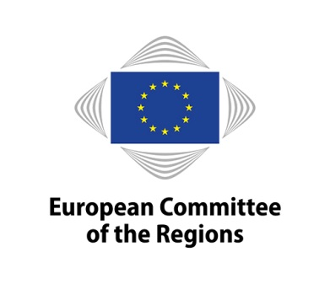 |  | Commission for Territorial Cohesion Policy  and EU Budget
Communication Stakeholders Consultation Meeting

"Better Communication for Cohesion Policy"
AGENDA
4 June 2019

European Committee of the Regions, Room JDE 51
Rue Belliard 99-101, Brussels

Cohesion policy is the main European investment policy to achieve the EU Treaty objective of economic, social and territorial cohesion. In that sense, better communicating Cohesion policy projects is very important as it can also affect citizens' perceptions of the EU and raise awareness on the positive impact the EU has on the everyday lives of people.

Communicating on cohesion policy is also a shared responsibility. Based on the respect of the partnership and multilevel governance principle, local and regional authorities should play a fundamental role in implementing cohesion policy and in ensuring the visibility of the projects funded by this policy. The European institutions alone cannot be the driving force behind this challenge.

The ongoing process of the preparation of the future programming period 2021-2027 offers a great opportunity to discuss the new provisions regarding communication within the proposal of the Common Provision Regulation post-2020. Increasing the visibility of ESI Funds can contribute to improving perceptions about the European Union and to regaining citizens’ confidence in the European Union.

This communication stakeholder consultation meeting will provide an opportunity to present the views of different actors (media companies, communication campaign managers, social media managers, public media relations, etc.) directly involved in communicating the results of EU co-funded projects, as well as to actively participate in the preparation of the Opinion on "Better Communication for Cohesion policy" leaded by Mr Adrian Ovidiu Teban (EPP/RO).

This meeting forms also part of the activities of the European Committee of the Regions promoting the #CohesionAlliance for a strong, effective and more visible cohesion policy beyond 2020.

Language regime: English

4 June 2019 - 10.00 – 11.30
European Committee of the Regions
Room JDE 51

AGENDA

9.30 – 10.00 Registration

10.00 – 10.15 Welcome and Opening Statement

- Adrian Ovidiu Teban (EPP/RO), CoR rapporteur on "Better Communication for Cohesion policy"

10.15 – 11.15 Communication Activities on Cohesion Policy

- Dana Spinant, Director of Budget, Communication and General Affairs, Directorate General for Regional and Urban Policy (DG REGIO), "Communication Actions on Cohesion policy" (tbc)

- Thomas Wobben, Director on Legislative Works, Committee of the Regions, #CohesionAlliance

- Gauthier Bas, Managing director, Old-Continent Agency, Results of "COHESIFY project".

- Nicolas Le Polain, Ground Game Coordinator for the European Elections, European Parliament, "New ways of communicating towards the citizens"

11.15 – 11.30 Discussion with the Audience

11.30 Conclusions

