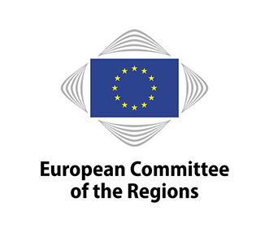
INFORMATION SESSION
2019 Connecting Europe Facility (CEF) transport call for proposals

7 February 2019, 14:00 – 15:30

European Committee of the Regions
rue Belliard 99-101, 1040 Brussels, meeting room JDE 52
Agenda

14.00 Welcome
Jiří Buriánek, Secretary-General of the European Committee of the Regions

14.05 Introduction: The potential of closing missing links of small scale infrastructure and how to finance it
Isabelle Boudineau, Chair of the CoR COTER Commission and CoR rapporteur on the "Connecting Europe Facility 2021-2027"
MEP Michael Cramer, Member of the EP-TRAN Committee

14.15 The policy context: Priorities of the call for Projects on the Comprehensive Network
João Ferreira, Policy Officer, Transport Investment, European Commission (DG MOVE)
Questions and Answers
15.00 The application, evaluation process and award criteria
Anita Kucharska, Deputy Head of Programme Support, Coordination & Communication Unit, Innovation and Networks Executive Agency (INEA)
Questions and Answers

The presentations will be in English only
Contact: CoR COTER Commission: coter@cor.europa.eu +32 2 28 22371

