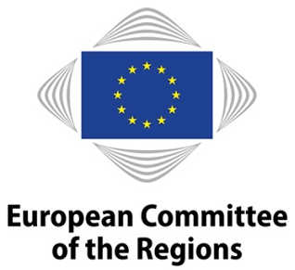
PROGRAMME

14 March 2023 | 10.00 – 12.00
Room JDE 51 (5th floor), Rue Belliard 99-101, European Committee of the Regions

CoR Opinion on Revision of the Urban Wastewater Treatment Directive
Stakeholder Consultation

Agenda

10.00 Opening statements

- Åsa ÅGREN WIKSTRÖM (SE/EPP), member of Västerbotten County Council, CoR rapporteur of the opinion, and member of the Commission for Environment, Climate Change and Energy (ENVE), European Committee of the Regions
- Oskar WIKSTRAND, Department of Growth and Urban Development, Swedish Association of Local Authorities and Regions, SALAR
- Oliver LOEBEL, Secretary General, EurEau

10.30 Panel discussion with the audience

11.50 Final remarks

12.00 End of the meeting

Participants may speak in & listen to English only

