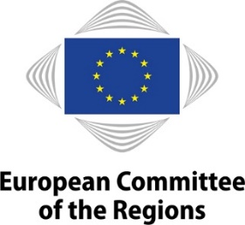
EN
NOTICE OF MEETING

WORKING GROUP "GREEN DEAL GOING LOCAL"

10th meeting
Friday, 13 May 2022
10 a.m. to 1 p.m. (Brussels time)
Hybrid meeting
Room: JDE51
Remote link to come
Interpreting available in: HU, DE, EN, FR, IT, PL

AGENDA

10 a.m. Opening

Opening by Kata Tüttő, Chair of the Green Deal Going Local working group

10.05 a.m. Discussion on the impact of the Russian war on Ukraine on the European Green Deal

Opening statements by:
- Alison Gilliland, Lord Mayor of Dublin
- Johannes Schilling, Team Leader, Energy Policy Steering and Coordination, DG ENER
- Harriet Bradley, Head of the CAP and Food programme at the Institute for European Environmental Policy

Discussion with the working group

11.10 a.m. Facilitating access to funds – Climate Bank roadmap

Opening statement by:
- Nancy Saich, Chief climate change expert, European Investment Bank

Discussion with the working group

11.40 p.m. Greening Our Mobility – DiscoverEU

Opening statement by:
- István Ujhelyi, Member of European Parliament, Chair of the DiscoverEU mentorship group
- Natascha Sander, Programme Manager for Youth Policy, Outreach and DiscoverEU, DG EAC

Discussion with the working group

12.20 p.m. Trees for Life – Local and regional authorities supporting the new EU Forest Strategy

Statement by:
- Csaba Borboly, President of Harghita County Council

Discussion with the working group

12.45 p.m. Closing
Closing by Kata Tüttő, Chair of the Green Deal Going Local working group

