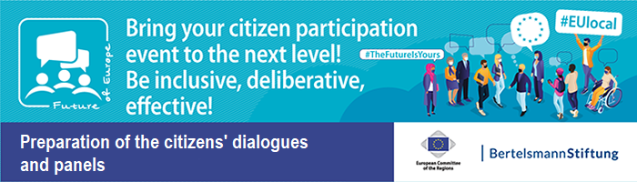
Collection of Materials on “Information for citizens” – Document 21

Example Worksheets for three topics

Citizens’ Dialogue in City, Date – Example Topic 1 “Social Europe”
Based on the example of three topics
Time-Example: 08:50 – 09:30 (40 min) First round of discussion at the tables
Participants talk about their experiences and opinions
Think about, for example, …
- …how you experience social living conditions in your home country.
- …how you feel about the freedom of movement for employees, access to
employment for EU citizens or social security.
- …what future problems you foresee when it comes to the EU’s social policies.
Collection of ideas: Collect topics and ideas about what should change
- What needs to change within EU politics for a Social Europe?
- How can we secure good jobs in a dynamic labour market?
- Can we combat social injustice with more solidarity and a common European social security standard?
- What can the EU do? What is important for us?
Result: The moderator notes down the topics/ideas on the poster.
Time-Example: 09:30 – 09:50 (20 min) Second round of discussions: change of tables
Exchange about the collection of ideas at the tables
- What did the citizens from the different countries talk about?
- What is important for our compatriots, and what is important for the others?
- What similarities and differences are there?

Time-Example: 09:50 – 10:40 (50 min) Third round of discussions at the tables
Discussion about the ideas and subsequently agreement on one topic/idea
- What topic is particularly important for a future Social Europe and why?
- Can we agree on one/two important topic(s) for our discussion?
- What does the EU have to do to promote this topic?
Result: The moderator adds definite ideas for implementation to the poster, and further topics.

Citizens’ Dialogue in City, Date – Example Topic 2: Digital Europe
Time-Example: 08:50 – 09:30 (40 min) First round of discussion at the tables
Participants talk about their experiences and opinions
Think about, for example, …
- … how you are personally confronted with digitalisation in your day-to-day life.
- … how you feel about digitalisation in the EU in particular.
- … what future problems you foresee when it comes to digitalisation in the EU.
Collection of ideas: Collect topics and ideas about what should change
- What needs to change within EU politics for a Digital Europe?
- How can we create new and innovative jobs?
- How can we recruit employees with digital competences?
- How can digital innovations be used for people?
- What can the EU do? What is important for us?
Result: The moderator notes down the topics/ideas on the poster.
Time-Example: 09:30 – 09:50 (20 min) Second round of discussions: change of tables
Exchange about the collection of ideas at the tables
- What did the citizens from the different countries talk about?
- What is important for our compatriots, and what is important for the others?
- What similarities and differences are there?

Time-Example: 09:50 – 10:40 (50 min) Third round of discussions at the tables
Discussion about the ideas and subsequently agreement on one topic/idea
- What topic is particularly important for a future Digital Europe and why?
- Can we agree on one/two important topic(s) for our discussion?
- What does the EU have to do to promote this topic?

Result: The moderator adds definite ideas for implementation to the poster, and further topics.

Citizens’ Dialogue in City, Date – Example Topic 3: Global Europe
Time-Example: 08:50 – 09:30 (40 min) First round of discussion at the tables
Participants talk about their experiences and opinions
Think about, for example, …
- … how you personally experience the EU on an international stage.
- … how you feel about the Global Europe topic in particular.
- … what future problems you foresee when it comes to globalization, international crises and national isolation.
Collection of ideas: Collect topics and ideas about what should change
- What needs to change within EU politics for a Global Europe?
- How can Europe stay competitive in comparison to other growing powers?
- What should Europe’s global role look like?
- What responsibility does the EU have when it comes to dealing with countries that have different values?
- What can the EU do? What is important for us?
Result: The moderator notes down the topics/ideas on the poster.
Time-Example: 09:30 – 09:50 (20 min) Second round of discussions: change of tables
Exchange about the collection of ideas at the tables
- What did the citizens from the different countries talk about?
- What is important for our compatriots, and what is important for the others?
- What similarities and differences are there?

Time-Example: 09:50 – 10:40 (50 min) Third round of discussions at the tables
Discussion about the ideas and subsequently agreement on one topic/idea
- What topic is particularly important for a future Global Europe and why?
- Can we agree on one/two important topic(s) for our discussion?
- What does the EU have to do to promote this topic?

Result: The moderator adds definite ideas for implementation to the poster, and further topics.

