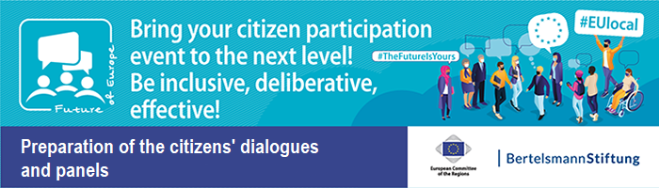
Collection of Materials on “Information for citizens” – Document 19

Example E-Mail Zoom links for citizens

Transnational Digital Citizens’ Dialogue
“Dialogue title”
With Citizens from “Country 1”, “Country 2”, “Country 3”, …
“Date”

Dear Sir or Madam,

We are looking forward to your participation in the Transnational Digital Citizens’ Dialogue!

For all participants from “Example - Ireland and Lithuania”: please note that all times listed below are indicated using the Central European Time zone (CET). In order to arrive at Irish local time:
–1 hour. In order to arrive at Lithuanian local time, +1 hour.

Your programme and dial-in details are as follows:

Day, Date (Day 1)

18:00 CET  18:30 CET | Join the plenary room for a technical check by clicking the link below:  https://Zoom Link plenary  ID: 12345678  Start of plenary meeting
19:20 CET  20:00 CET | Join your table group 1 meeting by clicking the link below:  https://Zoom Link table group 1  ID: 09876543  End of Day 1

Day, Date (Day 2)

17:30 CET  18:00 CET | Join the topic group 1 room for a technical check by clicking the link below:  https://Zoom Link topic group 1  ID: 121212121  Start of topic group 1 meeting - Topic
18:50 CET  20:15 CET | Join your table group 1 meeting by clicking the link below:  https://Zoom Link table group 1  ID: 09876543  End of Day 2
Day, Date (Day 3)

09:00 CET  09:30 CET | Join the plenary room for a technical check by clicking the link below:  https://Zoom Link plenary  ID: 12345678  Start of plenary meeting
10:00 CET | Join your table group 1 meeting by clicking the link below:  https://Zoom Link table group 1  ID: 09876543
12:15 CET  12:45 CET | Join the plenary meeting by clicking the link below:  https://Zoom Link plenary  ID: 12345678  Break
14:45 CET  16:15 CET | Join the plenary meeting by clicking the link below:  https://Zoom Link plenary  ID: 12345678  End of Day 3

Technical Hotline for questions:

Country 1 +45 12345678
Country 2 +46 23456789
Country 3 +47 34567890
Country 4 +48 45678901
….. +49 56789012

