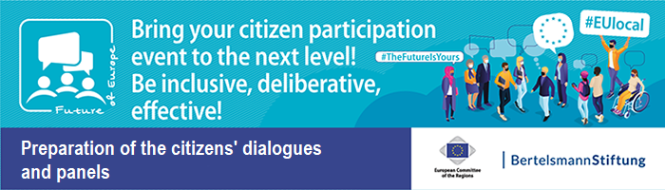
IT Instruction for Transnational Citizens' Dialogues

Collection of Materials on “Information for citizens” – Document 18

Transnational Digital Citizens’ Dialogue
“Topic of the Dialogue”
With Citizens from Country 1, Country 2, Country 3, Country xy

Dear Sir or Madam,
we look forward to welcoming you for the Transnational Digital Citizens' Dialogue!

Note on technology

You will need a
PC or laptop
with camera, microphone and loudspeaker.

Ideally use a headset for better communication!

Please ensure a stable internet connection.

Please make sure you have the latest version of Zoom downloaded: [5.7.4] (see below for instructions). Without the update, the interpreting function of Zoom will not work properly.

Your participation step-by-step: Participation via Zoom

- To use the interpreting function of Zoom, you must download the latest version of the programme here:
https://zoom.us/download

  - Search for: "Zoom Client for Meetings" and press "Download”

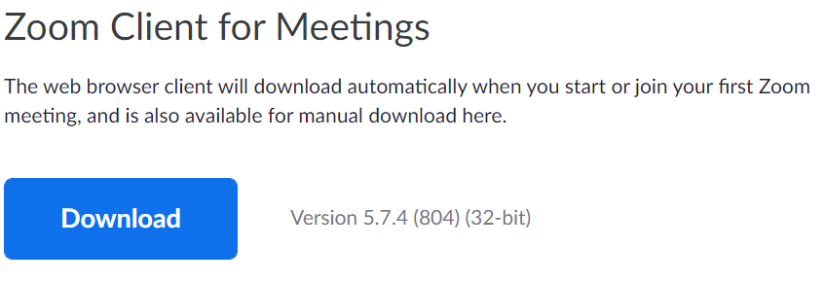

  - Depending on the browser you are using you should now either:
    - At the bottom of your window the file "Zoominstaller.exe" is displayed, please double click it to activate the installation
  - Or your browser asks you if you want to open the installation file or just save it, please press "Open". (attention: graphic in German!):

  - The installation of the programme should now run automatically

  - Important: Please install the program even if you have recently used Zoom to make sure you are working with the latest version

- To participate, follow the respective link for the session, e.g. the link to the plenary session:

https://Zoom Link 1234567890

  - Click on the link directly or copy it into your browser to open it there.

  - If you did not fully download and install the programme in the first step, the following window may appear (attention: graphic in German!):
Please click here
    - In this case, please follow the instructions and install the program

Please enter your first and last name, as well as your role or institution.

Example:
James Smith – Moderator

  - You will then be asked to enter your name.
(attention: graphic in German!):

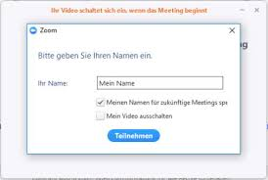

  - After clicking the "Join" button, the prompt "Join the audio by computer" appears. Click on it.
Please select

  - You will then enter a waiting room and see this picture.

Please be patient, it may take a few minutes for the moderator to let you in.

  - After you joined the Digital Citizens' Dialogue, please activate your camera!

Please click here

Your video is now switched on

  - After you have activated your camera, select your language:

When problems occur
If the registration does not work automatically and you cannot join the meeting via the link:
      - Please open your Zoom App (you can find it in the program list of your PC)
      - Click "Join a meeting".
Please click here
      - Now enter your name and the meeting ID which you can find in your link list under the meeting link.
      - Upon entering the meeting room, you will be prompted to join the meeting with your computer audio on. Please confirm this.
Please click here

Detailed information on how to use Zoom can be found here:
Joining a meeting – Zoom Help Center

We are looking forward to the mutual exchange!

