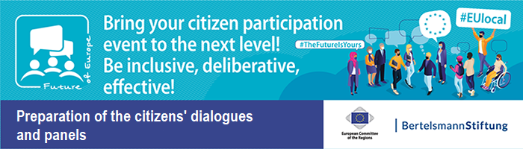
Collection of Materials on “Evaluation and digital Surveys” – Document 10

Example for evaluation sheet for citizens

Your opinion counts! Please give us your feedback on the Citizens’ Dialogue
- How do you assess today’s event with regard to the following points?
 | Very good |  | Good | Satisfactory | Moderately | Bad
The entire event as such.
The various methods used (table discussion, voting etc.).
The (cross-border/European/…) character of the event.
The contents of the discussion.
The relevance of the topics discussed.
The chance to exchange views on important (cross-border/European/ …) topics.
The exchange of views with EU citizens with different origins and opinions.
The chance to gain a better understanding of other EU citizens’ point of view.
The participation of politicians in the discussion rounds.
The politicians’ willingness to listen to citizens.
- What did you particularly like about the event?

- What could have been better?

- How satisfied are you with the European Union?
Very satisfied | Mostly satisfied | Undecided | Mostly dissatisfied | Dissatisfied

- How satisfied are you with democracy in the European Union?
Very satisfied | Mostly satisfied | Undecided | Mostly dissatisfied | Dissatisfied
- In your opinion, how strong are politicians’ interests in citizens’ issues and concerns?
Very strong | Strong | Moderate | Not strong | Non-existent

