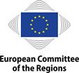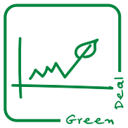

16 March 2021

|  |
| --- |
| **Green Deal Going Local Roadmap 2021** |

[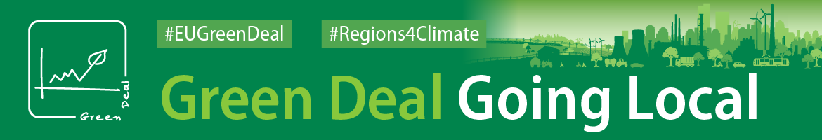](https://cor.europa.eu/en/engage/Pages/green-deal.aspx)

# **Introduction**

The European Green Deal is the flagship initiative of the European Commission, aiming to make Europe the first climate neutral continent and has been recognised as a priority by the CoR[1]. The transition towards climate neutrality calls for a concerted effort in a wide array of policy areas, which requires a new approach to policy design and implementation: the Green Deal Going Local (GDGL) working group is a key instrument in enabling a fully horizontal and inclusive approach to the CoR’s efforts on the Green Deal. The objectives of this 2021 Green Deal Going Local Roadmap is to create a structured framework for the 2021 work of the GDGL working group and of the Green Deal Task Force; in particular, the Roadmap aims to:

* Create a **consistent and coherent framework for CoR work on the Green Deal**, fostering **synergies between CoR services**;



* **Facilitate communication** of CoR actions on the Green Deal and **generate added value from the Green Deal Going Local 'label'**;
* **Facilitate strategic steering and stock-taking** through milestones and priorities for each area of the Green Deal;
* Ensure **consistency in inter-institutional cooperation**;
* Give Members and Rapporteurs a better idea of the **“big picture” on the Green Deal**.

# **Key achievements in 2020**

The GDGL working group was established to achieve three main objectives:

* To **ensure consistency and coherence in the CoR’s legislative work** on the Green Deal;
* To engage and cooperate with Green Deal high-level representatives for **other EU institutions and beyond**;
* To **boost communication** and promote best practices of the Green Deal Going Local;

Legislative consistency and coherence:

**In 2020 26 Green Deal opinions**, touching on a range of policy areas across all six CoR commissions, were adopted. The Green Deal Going Local working group facilitated exchanges and set in place administrative measures to ensure a consistent strategic approach across Green Deal opinions. Notably, the second meeting of the working group, organised in part as a public and interactive session of the European Week of Regions and Cities[2], was focused on an **exchange with rapporteurs on Green Deal opinions representing each of the six commissions**. Three **Green Deal debates** were also organised as part of the Plenary sessions in 2020 to ensure that all CoR members can contribute to the dialogue on the Green Deal.

Inter-institutional cooperation:

The CoR made sure that its efforts on the Green Deal reach the relevant institutional partners and contribute to the development and implementation of the Green Deal in general. **Each meeting of the Green Deal Going Local hosted key institutional partners**, including representatives of the European Commission and the European Parliament, and opened the window for a stronger cooperation on the Green Deal.

Cooperation with the European Commission on the Green Deal was developed on a wide variety of Green Deal related areas on administrative and political levels. Out of these, on the back of a Green Deal debate with Executive Vice-President Timmermans, **an enhanced cooperation with relevant Directorates-General was mapped on three priority areas:**

* **The Renovation Wave**
* **Sustainable Mobility**
* **Urban Greening/Climate Adaptation**.

Apart from exchanges with members of the European Parliament on relevant Green Deal opinion, the first meeting of the Green Deal Going Local working group hosted the Chair of the **Parliament’s ‘Green New Deal’ Intergroup**, opening a window to further deepen this cooperation.

The CoR has also supported the **German Presidency of the Council**, responding to two referrals directly relating to the Green Deal and hosting the German Federal Minister for the Environment, Nature Conservation and Nuclear, Ms Safety Svenja Schulze, at the December Plenary session Green Deal debate.

Communication outreach:

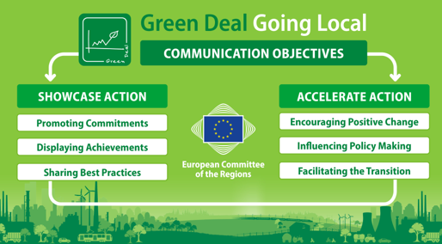The CoR has placed the EU's transition towards climate neutrality within its top political and communication priorities. As a communications initiative, GDGL is driven by clear goals and a four-pillar strategy that contributes to the objectives of the CoR Campaign 'Building Resilient Communities'. In communication terms, the CoR aims at **showcasing and accelerating action, displaying how cities and regions are already delivering the green transition on the ground** and replicating best practices across the EU as to foster the transition towards climate-neutrality.

The launch of the GDGL working group[3] was supported by a set of communication products in addition to a **member-centric press and social media campaign**, including a dedicated web-page[4], which has gotten more than 7000 views, and a distinctive branding for the GDGL, derived into a new visual identity. This member-centric approach to communication also put the spotlight on rapporteurs with a total of **18 Green Deal web interviews** published in 2020 and country-tailored press campaigns in addition to the engagement of EU Brussels-based media. CoR members also responded to a **call for best Green Deal practices**[5], submitting 200 practices and examples that were also published on the CoR interactive map[6].

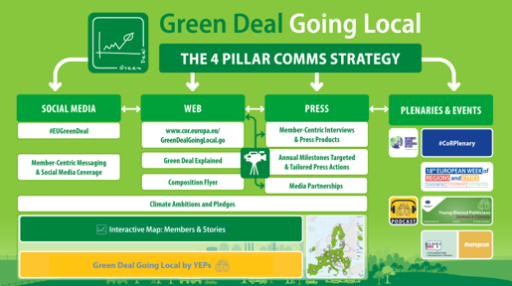Almost half of the press releases in 2020, 68 out of the 142 in total, were on Green Deal related topics with 25% of total CoR press coverage being on the Green Deal. 348 CoR social media posts were made in 2020 on Green Deal related topics, leading to more than 22 000 engagements.

The Call for Climate Pact Ambassadors was also launched in December 2020 in close partnership with the European Commission is also preparing the ground for boosting the activities and visibility of CoR members in the field of the Green Deal: the development of a Green Deal profile for members under the CoR4Climate Pact project will support a tailor-made approach to members' engagement in the Green Deal.

# **Green Deal Going Local priorities for 2021**

To ensure a focused approach and to maximise impact, the working group has outlined the following Green Deal priorities for 2021:

1. **Mainstream and reinforce cooperation with the European Commission on the Green Deal** – move forward on the three priority areas of cooperation with the Directorate-Generals for Energy, Environment and Mobility and Transport. Ensure that all relevant CoR commissions support cooperation on cross-cutting fields, such as the Renovation Wave;
2. **Cooperate with the European Parliament on upcoming legislation on the Green Deal priorities** – reinforce cooperation between the CoR commissions and the relevant Parliament commitees, notably the AGRI, ECON, ENVI, ITRE, REGI and TRAN committees. Promote cooperation with the relevant Parliament intergroups, such as the Green New Deal intergroup, the RUMRA & Smart Villages[7] intergroup and the intergroup on Climate Change, Biodiversity and Sustainable Development[8];
3. **Support the Portuguese and Slovenian Presidencies of the Council** – pursue a stronger cooperation with the Council on the Green Deal and ensure a horizontal contribution to the Presidencies' referrals on the Green Deal. Support exchanges with the Portuguese and Slovenian Presidencies on the Green Deal at Plenary sessions, relevant commission and working group meetings;
4. **Promote the Green Deal at a global level** – ensure that an inclusive approach towards tackling climate change is represented at the global stage, most notably the UNFCCC COP 26 and the CBD COP 15. This also includes supporting progress on the UN Sustainable Development Goals;
5. **Move towards a climate-neutral CoR** – promote the adoption of modern solutions and the lessons learned from the COVID-19 crisis to support the transition of the CoR to a modern and green administration.

Apart from the priorities, the CoR will also maintain consistency of work and cooperation on other areas of the Green Deal. This includes supporting cooperation between the CoR commissions and relevant Commission Directorates-General on Green Deal related topics, as well as the cooperation with relevant NGOs and Permanent representations. This also extends to cooperation to promote a green recovery from the COVID-19 crisis, including the promotion of the local and regional aspect on Green Deal objectives within the Recovery and Resilience Facility.

The CoR and the GDGL working group will ensure that their strategic priorities are attuned to those of the institutional setting in order to best reinforce the role of local and regional authorities within the Green Deal. This includes taking into account the European Commission Work Programme, as well as the priorities of the Portuguese[9] and Slovenian[10] Presidencies of the Council.

To ensure consistency of work and increase the exploitation of synergies work in-house, the Task Force on the “Green Deal Going Local” will cooperate with the relevant Task Forces, notably with Task Force 1 – Strategic Planning, Task Force 4 – Conference on the Future of Europe and Task Force 9 – Better Regulation and Fit4Future.

The Green Deal Going Local working group will also exchange information with the UK contact group.

# **2021 Calendar and main milestones**

The Green Deal Task Force will work throughout 2021 to ensure that the work over these different priorities is consistent across commissions and across services.

The overall planning for the GDGL in 2021 is the following[11]:

|  |  |  |
| --- | --- | --- |
| February | | |
| 26 February | High Level Conference on Implementing the European Climate Law |  |
| 17 February | * Trade Policy Review | |
| 24 February | * Communication on Better Regulation; * Action plan on the implementation of the European Pillar of Social Rights; * EU Adaptation Strategy. | |
| March | | |
| 15 March | Meeting of the Employment, Social Policy, Health and Consumer Affairs Council |  |
| 16 March |  | Bureau:  Adoption of the Work Programmes of CoR Commissions, platforms and networks for 2021 |
| 17-19 March |  | Plenary:  Green Deal Debate on the Renovation Wave (tbc)  Adoption:   * A Renovation Wave for Europe - greening our buildings, creating jobs, improving lives; * Action Plan on Critical Raw Materials; * A new approach to the Atlantic maritime strategy – Atlantic action plan 2.0; * European Education Area by 2025.   Launch of the Climate Pact Ambassadors |
| 29 March | European Year of Rail Launch |  |
| 1st Quarter 2021 | * Action plan for the development of organic production: on the way to 2030; * Europe’s digital decade: 2030 digital targets; * Renewed partnership with the Southern Neighbourhood; * Action plan on the European Pillar of Social Rights. | |
| April | | |
| 7 April | High Level Conference on Green Hydrogen |  |
| 13-15 April | ICLEI World Congress 2021 |  |
| 13-16 April | Working Party on Energy |  |
| 15-16 April | Working Party on Environment |  |
| 2nd Quarter 2021 | * Fit for 55 Package   + Revision of the EU Emissions Trading System (ETS);   + Carbon Border Adjustment Mechanism;   + Amendment to the Renewable Energy Directive;   + Amendment of the Energy Efficiency Directive;   + Effort Sharing Regulation;   + Revision of the Regulation on the inclusion of greenhouse gas emissions and removals from land use, land use change and forestry;   + Revision of the Directive on deployment of alternative fuels infrastructure;   + Revision of the Energy Tax Directive;   + Revision of the Regulation setting CO2 emission performance standards for new passenger cars and for new light commercial vehicles. * Zero pollution action plan for water, air and soil; * Updating the new industrial strategy for Europe; * Communication on the global approach to research, innovation, education and youth; * Communication on the long-term vision for rural areas; * Minimising the risk of deforestation and forest degradation associated with products placed on the EU market; * Establishment of an EU green bond standard; * New Pact on migration and asylum. | |
| May | | |
| 5-7 May |  | Plenary:  Green Deal Debate on Urban Greening and Zero-pollution (tbc)  Adoption:   * Powering a climate-neutral economy: An EU Strategy for Energy System Integration; * Safe and sustainable chemicals for a toxic-free environment in Europe's cities and regions; * Marine environment. |
| 14 May | High Level Forum on Sustainability and Tourism |  |
| 17-30 May | CBD COP 15 Kunming |  |
| 31 May – 4 June | EU Green Week |  |
| (tbc) |  | Cities and Regions for Development Cooperation Forum |
| June | | |
| 3-4 June | High Level Stakeholder Conference on R&I for a Sustainable Ocean |  |
| 8 June | Ministerial Conference on Integrated Maritime Policy |  |
| 14 June | Meeting of the Employment, Social Policy, Health and Consumer Affairs Council |  |
| 22-26 June | EU Sustainable Energy Week |  |
| 30 June – 2 July |  | Plenary:  Green Deal Debate on Smart and Sustainable Mobility (tbc)  Green Deal Debate on Sustainable Development and Climate Targets (tbc)  Adoption:   * Sustainable and Smart Mobility Strategy; * Stepping up Europe’s 2030 climate ambition towards COP26; * The future of regional airports; * Resolution on CoR priorities for the European Commission Work Programme 2022. |
| (tbc) |  | 5th meeting of the Green Deal Going Local working group |
| (tbc) |  | Welcome event for the Second Chamber of the Covenant of Mayors |
| July | | |
| 3rd Quarter 2021 | * Directive on Intelligent Transport Systems; * Regulation on the trans-European transport network (TEN-T); * Rail Corridor Initiative, including the revision of the Rail Freight Corridor; * Development of post-Euro 6/VI emission standards for cars, vans, lorries and buses. | |
| August | | |
| September | | |
| (tbc) | President’s State of the Union address |  |
| October | | |
| 11-14 October |  | European Week of Regions and Cities |
| 12-14 October |  | Plenary:  Green Deal Debate on the UNFCCC COP 26: Global and Local Alliances for Climate Action (tbc) |
| (tbc) |  | Recovery and Resilience Forum |
| (tbc) |  | 6th meeting of the Green Deal Going Local working group |
| (tbc) | European Commission Work Programme for 2022 | |
| 4th Quarter 2021 | * Directive on Intelligent Transport Systems; * Sustainable products policy initiative; * Circular electronics; * New legal framework on the restoration of healthy ecosystems; * Action plan for the social economy; * Fit for 55 Package:   + Revision of the energy performance of Buildings Directive;   + Revision of the Third Energy Package for gas. | |
| November | | |
| 1-12 November | UNFCCC COP 26 Glasgow |  |
| 29-30 November |  | Cities and Regions for Development Cooperation Forum |
| December | | |
| 1-3 December |  | Plenary:  Green Deal Debate on A New Path for Rural Development (tbc) |

**Annex I - Thematic overview and priorities in 2021**

To ensure that the goal of climate neutrality is reached by 2050, the CoR must support the development and implementation of the **Green Deal** **on all** **areas, as defined by the European Commission**:

* Achieving climate neutrality;
* Sustainable transport;
* Preserving Europe’s natural capital;
* Transition to a circular economy;
* A zero-pollution Europe;
* From farm to fork;
* The transformation of agricultural and rural areas;
* Towards a modernised and simplified CAP;
* Leave no one behind (Just Transition);
* Financing the transition;
* Clean, reliable and affordable energy;
* Promoting the Green Deal in the neighbourhood.

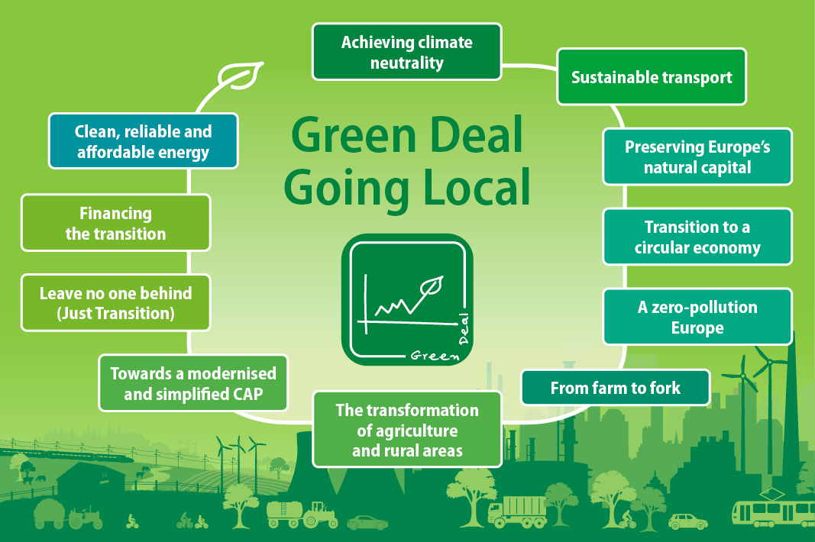

*Figure 1. Areas of the Green Deal Going Local*

The CoR undertakes many **different types of actions** to ensure that the Green Deal goes local. These actions can be grouped into four major categories:

* **Legislative works** – actions relating to the core CoR products, such as opinions;
* **Action Plans and cooperation** – actions focused on developing cooperation with key partners;
* **Communication activities** – actions focused on improving the visibility of CoR and LRA efforts;
* **Special activities** – actions relating to the CoR’s specific platforms and networks.

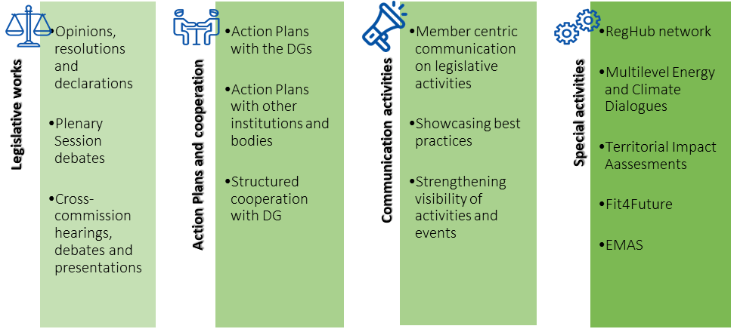

*Figure 2. Types of actions that support the Green Deal Going Local*

All these different types of actions can contribute to the Green Deal Going Local framework of the CoR and, as such, are considered within the Roadmap. Depending on what is achieved with each action, **all actions contribute to one of four objectives**:

* **Lead by example –** activities that contribute to showcasing what the CoR can do for the Green Deal as an institution (e.g. reducing emissions and encouraging sustainable transport);
* **Accelerate implementation –** activities that contribute to accelerating the implementation of the Green Deal and support the engagement of LRAs in Green Deal implementation (e.g. key partnerships that support project implementation);
* **Foster Active Subsidiarity –** activities that facilitate the inclusion of the sub-national viewpoint in the development of the Green Deal (e.g. activities that support the Better Regulation agenda);
* **Raise awareness –** activities that increase the visibility of LRA and CoR efforts on the Green Deal (e.g. communication campaigns and action plans).

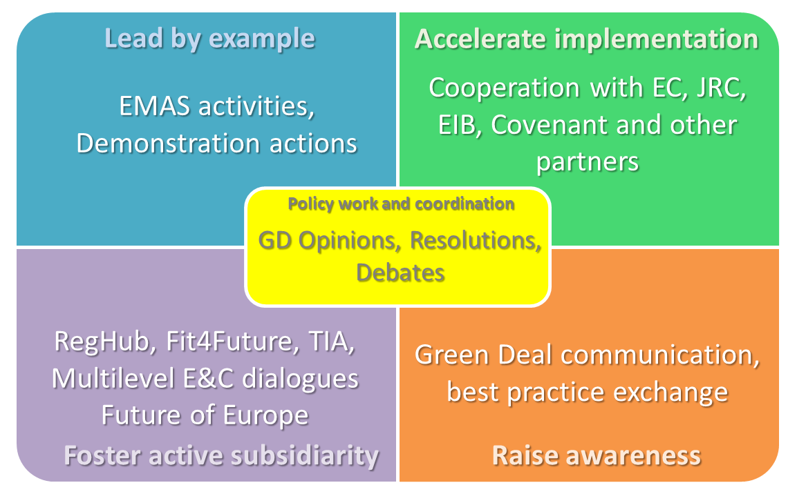

*Figure 3. Categorisation of main Roadmap activities*



1. **Achieving climate neutrality**

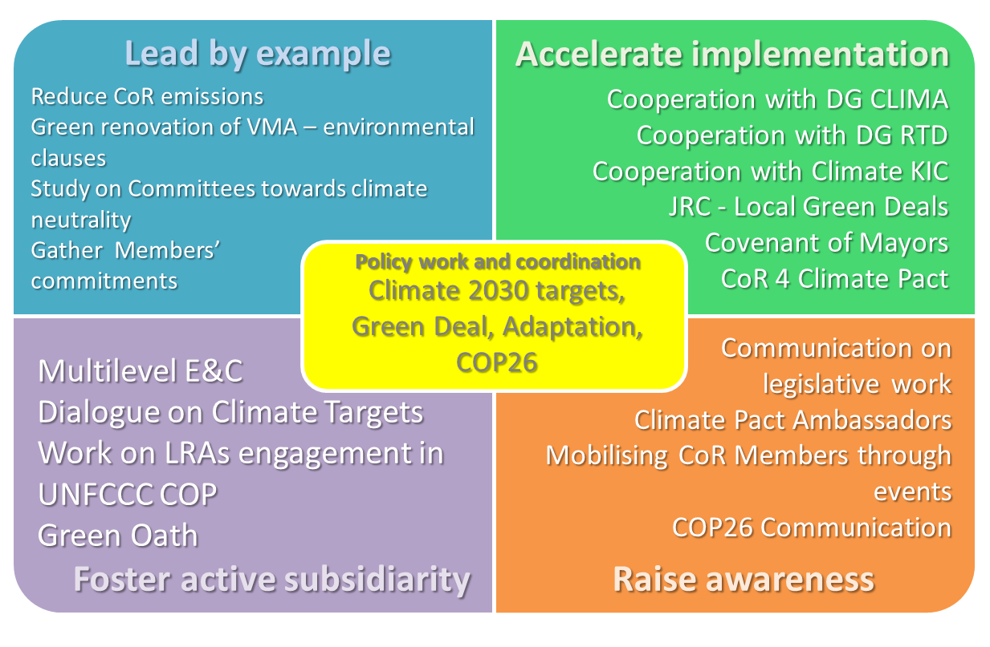

* + 1. **Overview**

The EU highlighted the need for ambitious climate targets as a fundamental requisite to protect the Planet and avoid irreversible changes to climate and ecosystems: these targets need a robust framework to make sure that they become a reality. Although explicitly tied to the mid and long-term climate targets, achieving climate neutrality depends on a number of interconnected activities. The EU Covenant of Mayors for Climate and Energy and Climate Pact are concrete examples of promoting the uptake of climate targets from LRAs and citizens alike. CoR Members, as local and regional decision makers will play a crucial role in the success of the Green Deal. The CoR also has a responsibility as an Institution to continue to lead by example through the implementation of new working methods and best practices with a view to becoming a climate neutral institution.

* + 1. **Priorities and milestones**

Priorities:

* Strengthen **cooperation with DG CLIMA and the Climate Kic**;
* Fully develop the **CoR 4 Climate Pact** project, including the setting up of **Climate Pact Ambassadors**, to ensure that the CoR is a valuable partner within the European Climate Pact framework;
* Strengthen **cooperation with DG RTD** and support the **Mission on Adaptation**;
* Cooperate with the **JRC** on the study on a **common framework for Local and Regional Green** **Deals** and a **Green Deal Scoreboard** for assessing and monitoring Local and Regional Green Deals;
* Promote the LRA level in the **UNFCCC COP26,** also making the most of the reinforced partnerships with relevant organisations as ICLEI, Under2Coalition and Regions4;
* Strengthen the position of LRAs within the **Covenant of Mayors**, notably within the announced 2nd chamber of the Covenant;
* Strengthen cooperation with **EP ITRE and ENVI Committees**;
* Promote the inclusion of the **‘Green Oath’** through the CoR’s activities on **Better Regulation**.

Potential policy work:

* Stepping up Europe’s 2030 climate ambition;
* Revision of ETS regulation;
* EU Adaptation strategy;
* Communication on Better Regulation.

Events:

* Multilevel Climate and Energy Dialogues;
* CoR event to support the Mission on Adaptation;
* Covenant of Mayors events
* Climate Pact Ambassadors events;
* Plenary session Green Deal debate;
* Dedicated events during EU regions week;
* UNFCCC Pre-COP and COP26.
  + 1. **Main synergies/cross-cutting activities**
* Harmonizing legislative work to contribute towards climate targets and mainstream climate objectives;
* Ensuring a significant CoR representation in the UNFCCC COP26;
* Ensuring a significant representation within the Climate Pact Ambassadors framework;
* Promoting CoR’s Better Regulation activities for Green Deal opinions, as well as the application of the ‘Green Oath – do no harm’ principle;
* Ensure consistency with the Urban Agenda Partnership on Climate Adaptation.

1. **Clean reliable and affordable energy**

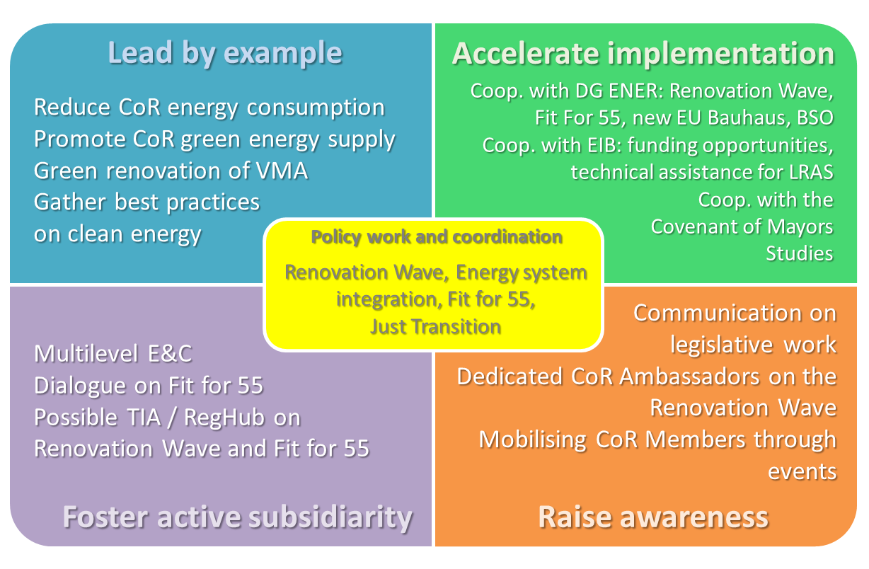

* + 1. **Overview**

The EU is looking at a comprehensive overhaul of its climate and energy policy by June 2021 and the CoR is ready to support it: the so-called “Fit for 55” package will have the aim of revising the entire Clean Energy package to ensure it is aligned with the new framework of the Green Deal, characterised by an increased ambition and a more transversal approach to sustainability. This success will largely depend on the capacity of the EU to understand the needs of EU territories in the post-pandemic context and design effective implementation mechanisms: the CoR will play a significant role in this sense. Within this framework one of the areas where LRAs have both the competences and the space to best contribute to the Green Deal is the Renovation Wave. As highlighted during Green Deal debate with Executive Vice-President Timmermans at the October 2020 Plenary session, the Renovation Wave is a priority area to establish a stronger cooperation between the CoR and the Commission.

* + 1. **Priorities and milestones**

Priorities:

* Develop an **‘enhanced cooperation’ with DG ENER on the Renovation Wave**, with the core elements of:
  + **Technical assistance:** Setting-up of **regional One-Stop-Shops**, on the model of the EIB ELENA facility;
  + **Investments:** Participation to **Sustainable Energy Investment (SEI) Forums**;
  + **Just Transition:** Discussing the issue of **energy poverty** in the framework of the Renovation Wave;
  + **Funding:** Discussing the mainstreaming of the Renovation Wave into the **Recovery and Resilience Plans**;
  + **Mobilization:** Discussion on the role of **bottom-up initiatives** in the implementation of the Renovation Wave.
* Provide local and regional viewpoint for the **‘Fit for 55’ package**;
* Strengthen cooperation with **EP ITRE Committee**.

Potential policy work:

* The ‘Fit for 55’ Package:
  + Revision of the EU Emissions Trading System (ETS), including maritime, aviation and CORSIA as well as a proposal for ETS as own resource;
  + Effort Sharing Regulation;
  + Amendment to the Renewable Energy Directive & Amendment of the Energy Efficiency Directive;
  + Revision of the Regulation on the inclusion of GHG emissions and removals from LULUCF;
  + Reducing methane emissions in the energy sector;
  + Revision of the Directive on deployment of alternative fuels infrastructure;
  + Revision of the Regulation setting CO2 emission performance standards for new passenger cars and for new light commercial vehicles;
  + Revision of the energy performance of Buildings Directive;
  + Revision of the Third Energy Package for gas (Directive 2009/73/EU and Regulation 715/2009/EU) to regulate competitive decarbonised gas markets;
* Powering a climate-neutral economy: An EU Strategy for Energy System Integration;
* A Renovation Wave for Europe.
* Revision of TEN-E regulation

Events:

* Multilevel Climate and Energy Dialogue;
* Covenant of Mayors events;
* Plenary session Green Deal debate;
* Climate Pact Ambassadors events;
* EU Sustainable Energy Week.
* Dedicated events during EU regions week.
  + 1. **Main synergies/cross-cutting activities**
* Cross-pollination between energy-related platform as Covenant of Mayors and Coal Regions with other relevant initiatives from other sectors as the Just Transition Platform and the Green City Accord;
* Continue to promote a circular approach to buildings’ renovation;
* Promotion of the cultural dimension of the energy transition through the new Bauhaus;
* Promotion of a just energy transition through a specific focus on energy poverty;
* Monitoring and analysis of state aids in the energy field;
* Ensure consistency with the Urban Agenda Partnership on Energy Transition.

1. **Sustainable transport**

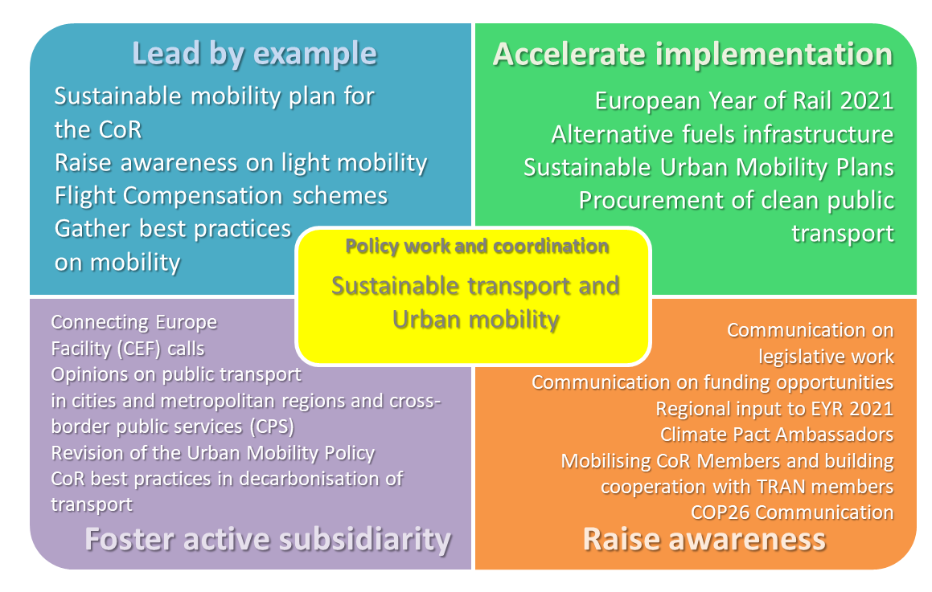

* + 1. **Overview**

Sustainable mobility is another priority area for the Green Deal Going Local where there is an envisaged enhanced cooperation with the Commission. Due to the nature of this area, as well as its impact on the overall climate targets, sustainable mobility has synergies with many other Green Deal areas. Building on previous years’ legislative work, the CoR will aim to promote sustainable mobility from a wide array of angles, from rail transport to promoting the availability of alternative fuels. The CoR will also not be able to achieve its institutional climate objectives without an ambitious transport policy and should look at reducing the emissions of staff and members.

* + 1. **Priorities and milestones**

Priorities:

* Explore the and develop an **enhanced cooperation with DG MOVE**;
* **Revision of Urban Mobility policy**, including the design of **Sustainable Urban Mobility Plans (SUMPs)**;
* Ensure active involvement of local and regional partners within the **European Year of Rail 2021** and showcasing the priority aspects highlighted by LRAs in relation to the EU's ambitious shift to rail objectives;
* Supporting the deployment of **alternative fuels** refuelling stations and other infrastructure aspects, especially in the forthcoming revision of the **trans-European Transport Network (TEN-T) Guideline**;
* Supporting the procurement and deployment of **clean public transport vehicles**;
* **Financing Sustainable Mobility**: mapping EU funding calls and providing relevant information to LRAs, also cooperating on the programming of co-funding for cross-border and missing links infrastructure projects **(CEF)**.

Potential policy work:

* Public transport in cities and metropolitan regions;
* Cross-border public services (CPS);
* Revision of the Directive on Intelligent Transport Systems, including a multimodal ticketing initiative;
* Revision of the Regulation on the trans-European transport network (TEN-T);
* EU 2021 Rail Corridor Initiative, including the revision of the Rail Freight Corridor Regulation and actions to boost passenger rail;
* Development of post-Euro 6/VI emission standards for cars, vans, lorries and buses.

Events:

* Climate Pact Ambassadors events;
* Plenary session Green Deal debates;
* Launch of the European Year of Rail.
  + 1. **Main synergies/cross-cutting activities**
* Synergies in promoting the development and relaunch of sustainable tourism (SEDEC) and outreach to young people in particular (DiscoverEU);
* Greening of cities clean public transport, shared mobility and reduction of individual transport modes, especially fossil-fueled ones;
* Strengthening the link between the future Urban Agenda for the EU and the European Green Dea, and ensure consistency with the Urban Agenda Partnership on Urban Mobility;
* Mainstreaming sustainable mobility in a more sustainable tourism, also with interinstitutional partners, such as the European Parliament's Tourism Task Force (TRAN);
* Ensuring consistency in the cooperation and activities with the Covenant of Mayors.

1. **Preserving Europe’s natural capital**

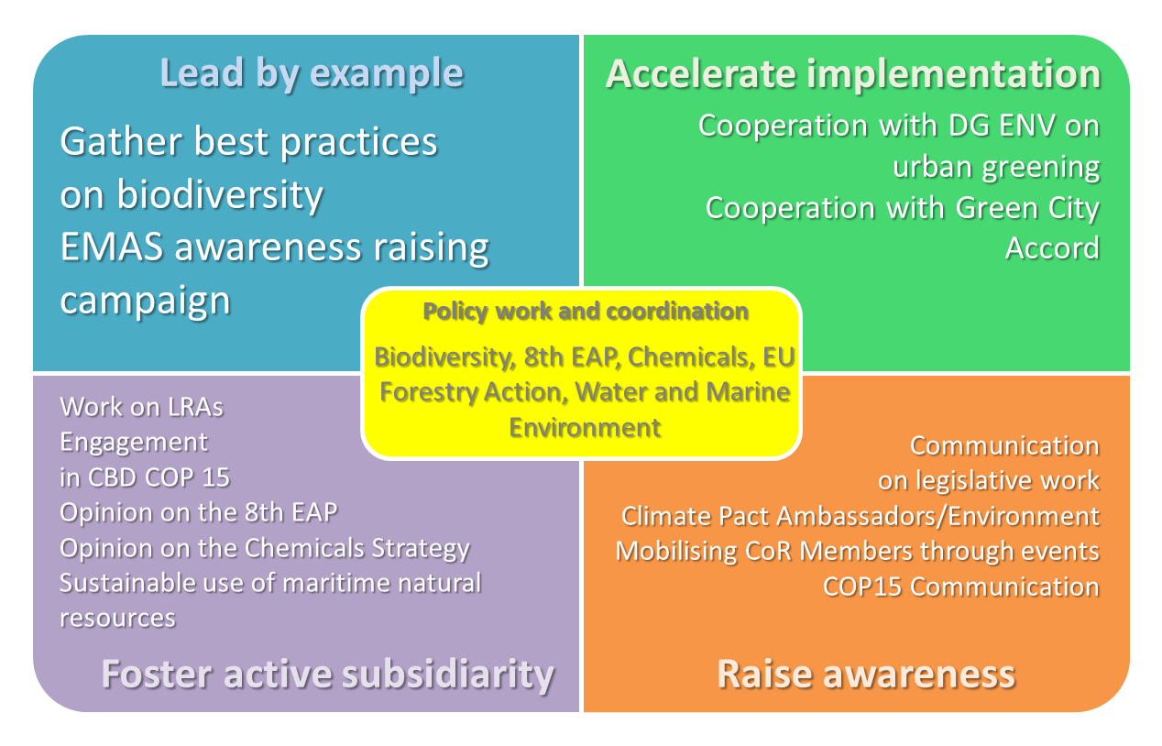

* + 1. **Overview**

The COVID-19 pandemic has highlighted the importance of preserving a rich and diverse natural capital. An important aspect, highlighted as one of the Green Deal Going Local priorities for an enhanced cooperation with the Commission, is promoting the greening of urban areas. Also, following up on the EU biodiversity strategy for 2030, the CoR will focus on the preparatory process toward the UN CBD COP15 and look into the restoration of degraded ecosystems. Covering also forestry and the marine environment, adequate coverage of this Green Deal area requires exploiting the synergies between a number of policy areas.

* + 1. **Priorities and milestones**

Priorities:

* Establish an **enhanced cooperation with DG ENV** on urban greening, including **upgrading the cooperation on the Technical Platform for Cooperation on the Environment** to become the Urban Greening Platform[12];
* Support the advancement of the **Green City Accord (GCA)** and the **Urban Greening Plans** defined under the GCA;
* Support and communicate LRAs engagement in the **CBD COP15**;
* Further promote a **sustainable blue economy** for EU’s coastal and maritime regions;
* Follow up on the **new EU Forest strategy** for the period after 2020, to ensure that the LRA viewpoint is considered.

Potential policy work:

* 8th Environmental Action Programme;
* New legal framework on the restoration of healthy ecosystems;
* A new approach to the Atlantic maritime strategy – Atlantic action plan 2.0, an updated action plan for a sustainable, resilient and competitive blue economy in the European Union Atlantic area;
* EU Forest strategy.

Events:

* Green week 2021;
* Plenary session Green Deal debate;
* CBD COP15;
* Climate Pact Ambassadors events.
  + 1. **Main synergies/cross-cutting activities**
* Harmonizing initiatives – GCA, Climate Pact, Covenant of Mayors, new 2030 Climate Targets framework;
* Coordinate action with actions on zero-pollution and circular economy;
* Explore and reinforce interconnections between climate action and environment action, especially between urban greening and climate adaptation;
* Strengthen link between forestry policy with climate, biodiversity and bio-based circular economy;
* Strengthen link between financing opportunities for Nature-Based Solutions and other financing opportunities and recovery funds relevant for the Green Deal.

1. **Transition to circular economy**

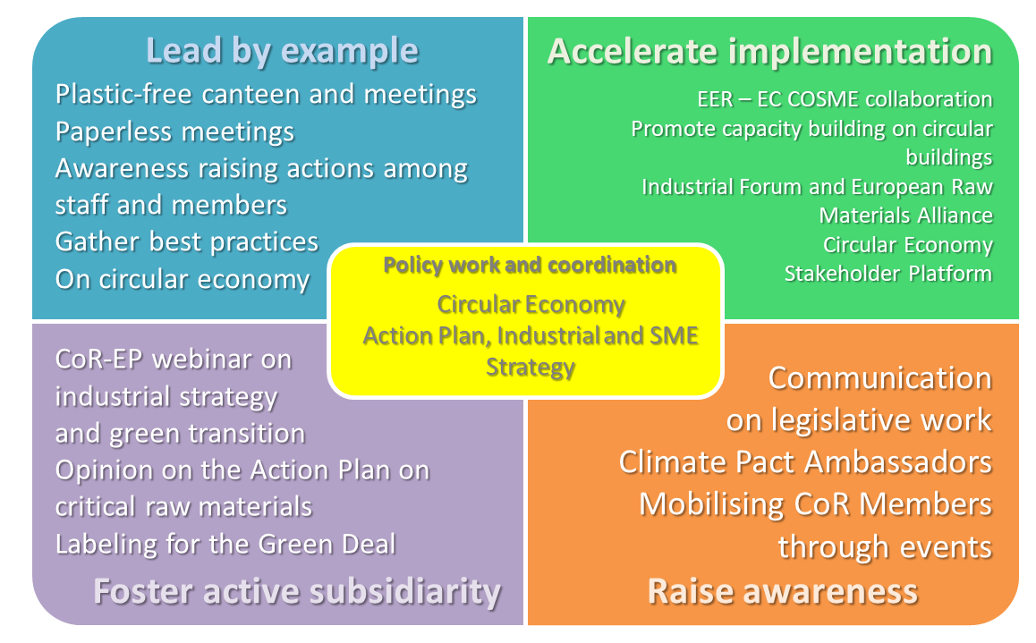

* + 1. **Overview**

The European Green Deal goes far beyond cutting emissions, and a move to a circular economy is a crucial element of the transition towards climate neutrality. This transition requires action on both the environmental aspects as well as ensuring that European industry is in line with the mid and long-term Green Deal targets. This area also opens a wide window for CoR to improve its contribution to the Green Deal as an institution on a wide variety of activities, including sorting and collection of waste, promotion of reusable and environmentally responsible materials.

* + 1. **Priorities and milestones**

Priorities:

* Raise awareness and capacity-building on the opportunities and challenges linked to the implementation of the **Circular Economy Action Plan**;
* Support CoR participation in the **Circular Economy Stakeholder Platform**[13] and support the implementation of measures foreseen in the **Circular Cities declaration**[14];
* Support development of **renewed industrial package**, including the **SME Strategy**, to facilitate a strong and coherent industrial policy for a more resilient, innovative and competitive Europe;
* CoR **European Entrepreneurial Region (EER) collaboration with COSME** on mapping and interlinking EER regions on circular economy ;
* Promote involvement of regional governments in the **Industrial Forum**[15] and the **European Raw Materials Alliance**[16].

Potential policy work:

* Circular Economy Action Plan;
* Sustainable products policy initiative, including a revision of the Ecodesign Directive;
* Circular electronics;
* Legislative proposals on waste (revision of the regulation on persistent organic pollutants in waste and revision of the packaging and packaging waste directive);
* Action Plan on Critical Raw Materials;
* Updating the new industrial strategy for Europe.

Events:

* CoR-EP webinar on ‘The New Industrial Strategy : Managing Transformation, Fostering Transition ; Towards a roadmap to assist the European Industry and the Regions in the Twin Transition;
* European Week for Waste Reduction;
* Climate Pact Ambassadors events.
  + 1. **Main synergies/cross-cutting activities**
* Legislative consistency between key dossiers, as per the priorities outlined above;
* Ensure information sharing from CoR’s participation in key platforms, as per the priorities outlined above;
* Informing all CoR members on opportunities to improve the CoR’s institutional contribution to circular economy.

1. **A zero pollution Europe**

 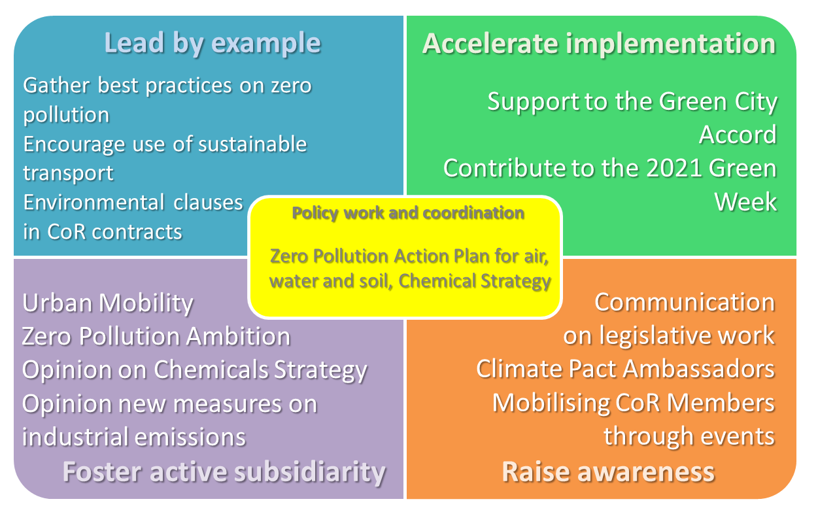

* + 1. **Overview**

Zero pollution is one of the three main environmental priorities within the Green Deal. The COVID-19 outbreak and the associated restrictive measures have led to an unprecedented reduction in pollution. Reductions appear to be temporary but the European citizens could see more clearly that a healthier environment, less traffic, more open public spaces and nature-based solutions are essential for their well-being. There is strong support for this historic opportunity to build something better.. The CoR will continue to move forward in making the Zero pollution ambition a reality through legislative work and participation in the 2021 Green Week, that is focused on the goal of zero pollution. The CoR is involved in the discussion on the creation of a new Zero Pollution Stakeholder Platform.

* + 1. **Priorities and milestones**

Priorities:

* Contribute to the **Zero pollution ambition for a toxic-free environment**, that includes the Zero Pollution Action Plan for air, water and soil, as well as the Chemical Strategy for Sustainability Towards a Toxic-Free Environment;
* Contribute to the **2021 Green Week**.

Potential policy work:

* Zero pollution action plan for air, water and soil; specific proposals and initiatives included in the plan;
* Chemicals Strategy for Sustainability Towards a Toxic-Free Environment;
* New measures on industrial emissions (in last part of 2021).

Events:

* 2021 Green Week with specific session co-organized by the CoR;
* Clean Air Forum 2021;
* Launch of new Zero Pollution Stakeholder Platform.
  + 1. **Main synergies/cross-cutting activities**
* Coordinate action with all relevant EU policies, especially with actions on climate targets, biodiversity strategy and circular economy; contribute to climate activities such as UNFCCC COP26 and Climate Pact Ambassadors events;
* Ensure consistency with actions on Sustainable Mobility, especially in view of urban mobility;
* Contribute to support the link between environment and health;
* Feed into the enhanced cooperation with DG ENV on Urban Greening and ensure that zero-pollution is considered. Support Green City Accord that includes air and water among its key areas.

1. **From farm to fork**

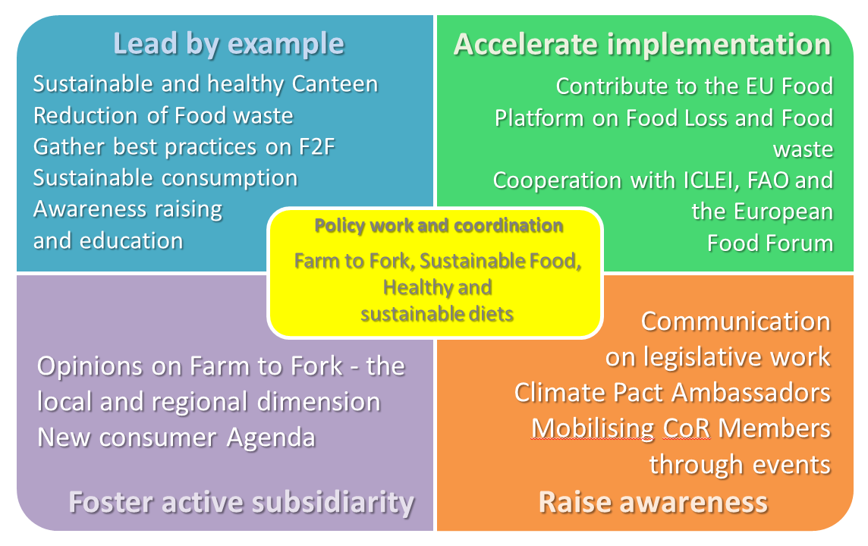

* + 1. **Overview**

Environmental impacts of food production and consumption are an important consideration in the Green Deal and the CoR has been pushing for a transition towards a more sustainable food system with a series of opinions on Farm to fork strategy, Sustainable food, Healthy and sustainable diets and Food waste. The Farm to fork strategy also outlines an important role for consumers to drive the changes towards more sustainable choices (including new labelling schemes) and make the shift happen in food systems and beyond. These improvements are also something that the CoR can implement within its day-to-day functioning, including further promoting measures to prevent food waste.

* + 1. **Priorities and milestones**
* Further promote ideas expressed from the **CoR opinion on the Farm to fork strategy**;
* Look into **initiatives** published by the European Commission as announced in the **Farm to fork strategy**, such as modalities for setting **minimum mandatory criteria for sustainable food procurement** to promote healthy and sustainable diets, including organic products, in schools and public institutions;
* Continue to contribute to the work of the **EU Food Platform on Food Loss and Food Waste**, led by the European Commission;
* Cooperate closely with the **European Commission**, the **European Parliament**, the **European Economic and Social Committee** and further develop relations with relevant stakeholders, such as the **FAO** and **ICLEI**;
* Cooperate with the **European Food Forum** by mutually feeding into the debates on the sustainable food systems, possibly co-organise an event on this topic;
* Promote **consumer awareness and education on sustainable consumption**;

Potential policy work:

* New consumer agenda.

Events:

* Climate Pact Ambassadors events;
* Green Deal Going Local working group meeting.
  + 1. **Main synergies/cross-cutting activities**
* Ensuring consistency with action on agriculture, rural areas and the CAP;
* Promote behavioural changes and ensure consistency with education activities in the framework of the just transition;
* Explore synergies with between sustainable food production and climate action, especially in the view of climate adaptation and Nature-Based Solutions;
* Reinforce synergies between sustainable food production and green procurement.

1. **The transformation of Agriculture and rural areas**

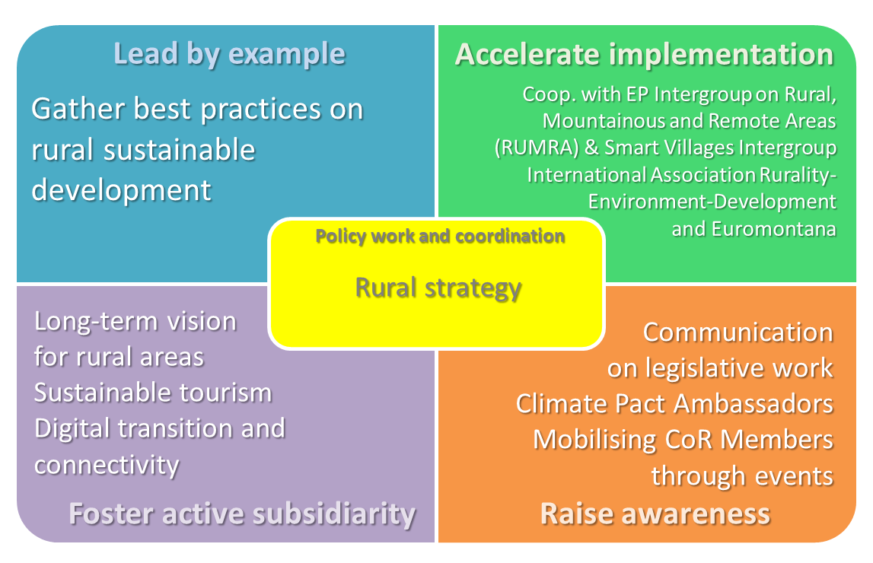

* + 1. **Overview**

The CoR has for a long time asked for the needs of rural areas to be recognised and addressed by a proper EU policy, and the COVID-19 pandemic has further added to the urgency to the quest for rural revival in regions across the European Union. They have also been more vulnerable as they have limited access to medical centres, hospitals, transport and poor or non-existent access to internet. The digital divide has especially impacted education and business. In order to increase the attractiveness of rural areas as a place to live and work, it is necessary to boost their recovery by better coordinating Common Agricultural Policy, ESI funds the Recovery and Resilience Facility and other relevant EU financing programmes.

* + 1. **Priorities and milestones**

Priorities:

* Stepping up cooperation with the **European Parliament** **AGRI**, **REGI** and **ENVI** committees on rural areas, also including the **RUMRA** & **Smart** **Villages** **intergroups**;
* Continue to promote **digital** **connectivity** and solutions at local and regional level in rural areas to counter the growing digital divide;
* Actively participate in the work of the **OECD Working Party on Rural Policy**;
* Work with **UNESCO** to support using world heritage as a tool to enhance the **economic** and **social sustainability of rural areas in Europe**;
* Cooperate with key partners, such as the **ENRD** Thematic Group on “The long-term rural vision”, **European** **Rural** **Parliament** and **National** **Rural** **Parliaments**.

Potential policy work:

* Long-term vision for rural areas.

Events:

* Joint meeting with the EP AGRI Committee on the new long-term vision for rural areas;
* Climate Pact Ambassadors events;
* .Plenary session Green Deal debate.
  + 1. **Main synergies/cross-cutting activities**
* Ensuring that rural areas fully benefit from the sustainable mobility transition (eg. alternative fuels infrastructure, access to public transport services) to support territorial cohesion;
* The European Year of Rail 2021 may bring further opportunities for collaboration around this thematic + sustainable tourism;
* Ensuring consistency with activities on the Just Transition and cohesion policy to promote territorial cohesion;
* Explore synergies for financing instruments for agriculture and rural development and financing instruments for other GD related projects.

1. **Towards a modernised and simplified CAP**

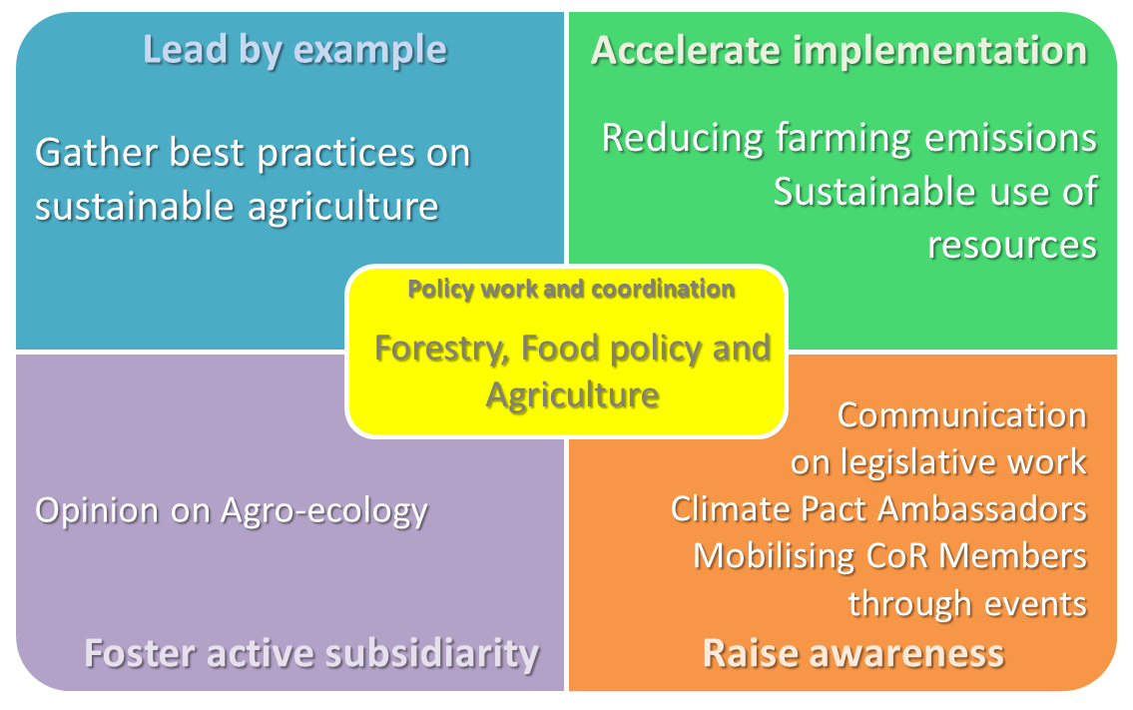

* + 1. **Overview**

Following the adoption of its opinions on CAP, the Farm to Fork Strategy and pastoralism, the CoR must continue its efforts to develop a more resilient and sustainable agriculture in order to achieve the Green Deal objectives and to strengthen the security of European food supplies.

* + 1. **Priorities and milestones**

Priorities**:**

* Participation in the Commission project on **Agroecology living labs**[17];
* Promoting **pastoralism** through **cooperation with associations** and by encouraging the **European Commission** to come up with an **action plan** to enhance pastoralism;
* Promote **organic farming** to support resilient and sustainable farming systems
* Promote the **CoR proposals to adapt the CAP to the objectives of the Green Deal**.

Potential policy work**:**

* Agroecology;
* Digitalisation in agriculture;
* Revision of geographic indications regulation.

Events:

* Climate Pact Ambassadors events;
* Green Deal Going Local working group meeting.
  + 1. **Main synergies/cross-cutting activities**
* Ensuring consistence with actions supporting the digital transition;
* Ensuring consistence with actions on rural areas and farm to fork.

1. **Leave no one behind (Just Transition)**

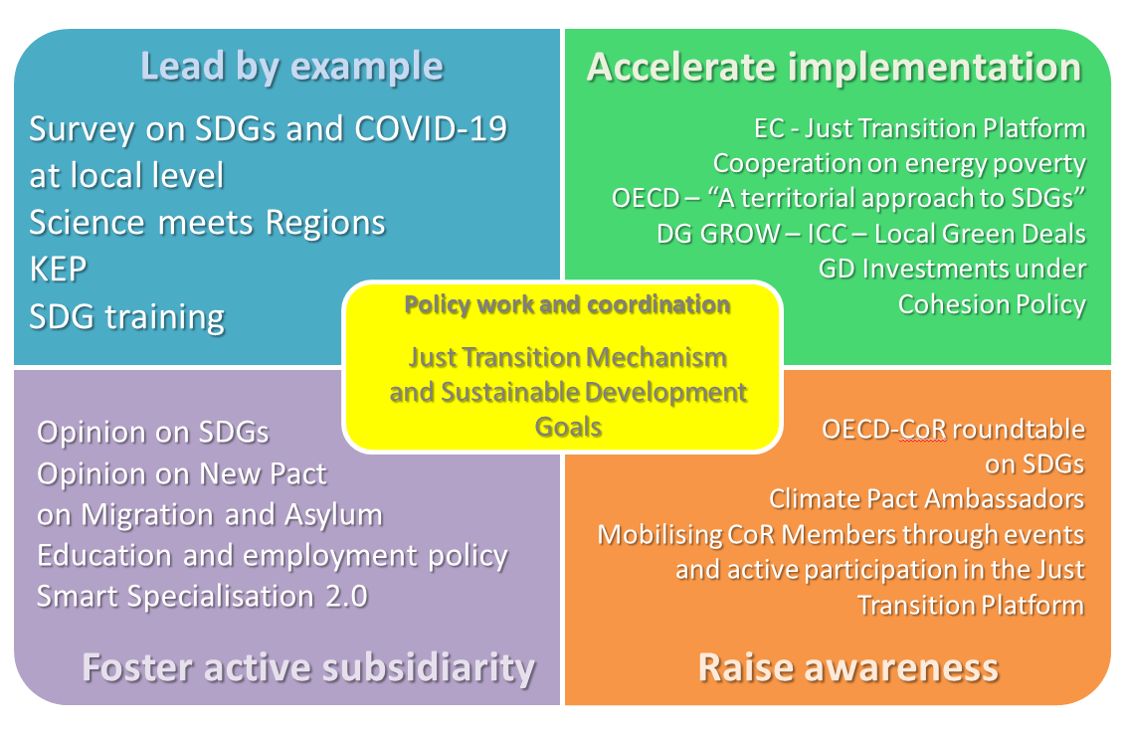

* + 1. **Overview**

An ambitious Green Deal can only succeed if it has a strong social dimension and happens in a socially balanced way. ‘Just transition’ must be an integral element of green policies in order to encompass a range of social interventions needed to secure workers' rights when economy is shifting to more sustainable ways of production. There is a close link between the social agenda, the Green Deal, and the digital agenda, given that the green and digital transitions must be based on social justice, equality and environmental sustainability – a fair labour market in the carbon-neutral economy of the future is needed, based on decent jobs, strong social protection, and job opportunities where people live. The aim is to achieve the United Nations Sustainable Development Goals and implement the European Green Deal in a way that is socially just.

* + 1. **Priorities and milestones**

Priorities:

* Support an **integrated CoR action on the Just Transition**, including:
  + Reinforce **cooperation with DG REGIO** on the Just Transition Platform, also carrying out dedicated joint sessions during Just Transition Platform meetings and defining;
  + Organise a **Multilevel Energy and Climate Dialogue** on the multilevel governance of the Just Transition;
  + Promote and disseminate **best practices of just transition projects** by CoR members within the Green Deal Going Local framework.
* Ensure that the usage of the **Just Transition Fund** and the **EU's Social Pillar** contributes to a just transition;
* Promote the implementation of the **European Skills Agenda** in order to meet the skills requirements of new professions, in particular those relevant to the green and digital transitions;
* Focus on **cooperation with the Commission (DG RTD and JRC)**, especially in view of the **Knowledge Exchange Platform (KEP)** and **Science meets Regions** – two large-scale inter-institutional projects that also focus on the Green Deal and its implementation locally;
* Develop closer cooperation with the **Joint Research Centre (JRC)**, including **ISPRA**, on Green Deal studies, on-site visits and provision of up-to-date indicators of implementation of the Green Deal;
* Support the new edition of **Smart Specialisation (2.0)** and promote the **RIS4 approach**;
* Cooperate with the **OECD** on their pilot project supporting cities and regions in translating SDGs at their level – **‘A territorial approach to SDGs’**;
* Promote the development of **Local and Regional Green Deals** through initiatives such as the **Intelligent Cities Challenge (ICC)**, and support the development of a **Green Deal Scoreboard**.

Potential policy work:

* The implementation of the EPSR from a local and regional perspective;
* Action Plan for the Social Economy;
* Delivering Sustainable Development Goals by 2030;
* European Education Area by 2025;
* New Pact on Migration and Asylum.

Events:

* OECD-CoR roundtable on SDGs;
* UNFCCC CAP26;
* UN SDG Summit;
* Multilevel Energy and Climate Dialogue;
* Climate Pact Ambassadors events.
  + 1. **Main synergies/cross-cutting activities**
* Promote inclusion of SDGs in all Green Deal areas;
* Address energy poverty to ensure a just transition, especially in the view of cooperating with DG ENER on the Energy Poverty Observatory;
* Ensure consistency between actions on the Just Transition Platform and actions on climate targets and energy, especially in view of Coal Regions;
* Ensure cross-commission cooperation on the Just Transition Mechanism, especially between COTER, ECON and ENVE.

1. **Financing the transition**

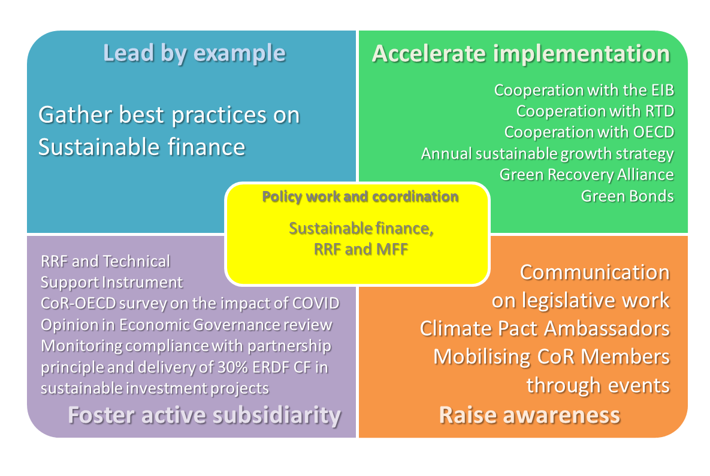

* + 1. **Overview**

In the aftermath of the massive socio-economic crisis caused by the COVID pandemic, it is of the utmost importance to ensure an effective and geographically balanced recoverym while not setting aside our ambitions for sustainable development. The CoR will work towards the integration of a territorial dimension within the RRF that should also address the transition to sustainability, including the Green Deal.

* + 1. **Priorities and milestones**

Priorities:

* **Assess and monitoring the recovery strategy**, including the **RRF** in all its elements, the **European Semester** and the **Economic Governance framework**, supported by a **CoR-CEMR survey** to national associations, as well as a **study** on the territorial dimension of NRRPs;
* Foster dialogue with decision-makers to encourage further inclusion of LRAs and sustainability,leading up toa **"Recovery and Resilience Forum"**;
* **Reinvigorate cooperation with the EIB to support** **sustainable investment** with a **renewed action plan** to help the EIB further reach out to LRAs;
* Support **financing sustainable transition** and ensure that RFF funds aimed at Green Deal goals benefit LRAs;
* Developing a resource for LRAs on financing Green Deal Projects within the **CoR 4 Climate Pact** initiative;
* Support LRAs in utilizing funding opportunities within the **Horizon Europe** framework, especially in the areas of:
  + green energy (esp. green hydrogen);
  + sustainable transport (electrification, smart grids, simulation – Living Labs (JRC));
  + green agriculture and sustainable acquacultures (data gathering and processing; digitisation of agriculture/fisheries);
  + data gathering and analysis (open science, data banks, improved indicators for sustainability).

Potential policy work:

* Renewed Sustainable Finance Strategy and Green Bond;
* Establishment of an EU green bond standard;
* The Carbon Border Adjustment Mechanism (CBAM) and a proposal for CBAM as own resource.

Events:

* Recovery and Resilience Forum;
* UNFCCC COP26;
* Climate Pact Ambassadors events.
  + 1. **Main synergies/cross-cutting activities**
* Ensuring synergies between Cohesion policy and the new European recovery tools;
* Promote Horizon Europe funding opportunities across different Green Deal activities ;
* Information sharing on Horizon Europe and the European Maritime and Fisheries Fund, who will work synergistically towards sustainable research and concrete outputs in the next programming period.
* Ensure consistency with actions on the Renovation Wave.

1. **Promoting the Green Deal in the neighborhood**

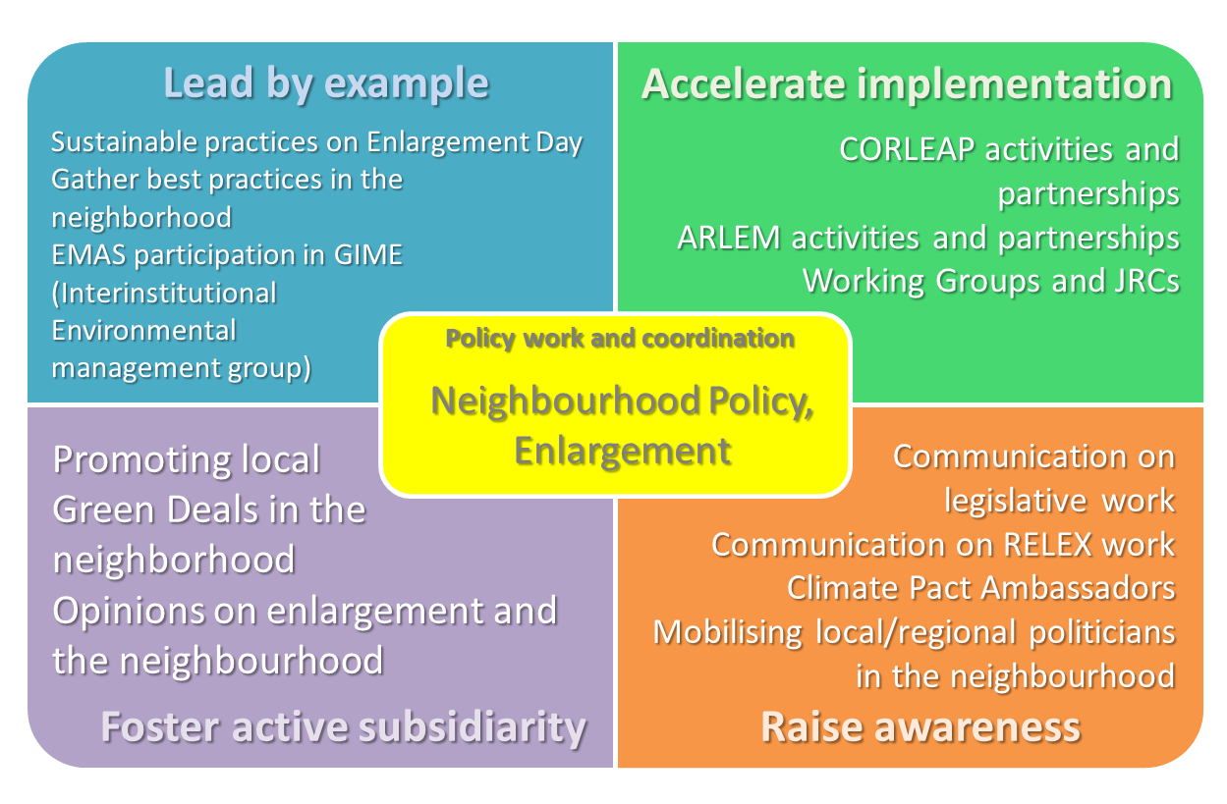

* + 1. **Overview**

The European Green Deal has more relevance than moving Europe towards climate neutrality and a more sustainable way of life – it is a clear signal that the EU is at the forefront in global climate diplomacy. As such, the Union must also promote these values within the European neighbourhood. The CoR has already set out on mainstreaming the Green Deal into its external actions.

* + 1. **Priorities and milestones**

Priorities:

* Promote the Sustainable Development Goals (SDGs) in the enlargement process, especially through the relevant Joint Consultative Committees;
* Promote the Sustainable Development Goals in the European Neighbourhood Policy through the Conference of Regional and Local Authorities for the Eastern Partnership (CORLEAP) and the Euro-Mediterranean Regional and Local Assembly (ARLEM);
* Developing a Green Deal for the Mediterranean within the ARLEM framework;

Potential policy work:

* Enlargement Package;
* Joint Communication on a renewed partnership with the Southern Neighbourhood.

Events:

* Enlargement Day 2021;
* UNFCCC COP 26 ;
* 7th Forum ‘Cities and Regions for Development Cooperation’
* Climate Pact Ambassadors events.
  + 1. **Main synergies/cross-cutting activities**
* Ensuring that CIVEX activities tied to promoting the Green Deal in the EU neighborhood are supported by the Green Deal Going Local working group;
* Information sharing of all CIVEX activities tied to promoting the Green Deal in the EU neighborhood to all CoR members;
* Promote cooperation with global initiatives, such as the Global Covenant of Mayors, the Under2 coalition, ICLEI World and Regions4.

1. RESOL-VI/038, The Green Deal in partnership with local and regional authorities, available at <https://cor.europa.eu/en/Documents/COR-2019-04351-00-00-RES-TRA-EN.pdf>
2. <https://europa.eu/regions-and-cities/programme/sessions/1812_en>
3. <https://cor.europa.eu/en/news/Pages/The-European-Green-Deal-is-Going-Local-.aspx>
4. <https://cor.europa.eu/en/engage/Pages/green-deal.aspx>
5. <https://cor.europa.eu/en/news/Pages/Green-Deal-Going-Local-call-for-best-practices.aspx>
6. <https://cor.europa.eu/EN/regions/Pages/eir-map.aspx?view=stories&type=greendeal>
7. <https://www.smart-rural-intergroup.eu/>
8. <https://ebcd.org/intergroup/>
9. <https://www.2021portugal.eu/en/programme/priorities/>
10. <https://www.gov.si/en/registries/projects/slovenian-presidency-of-the-council-of-the-eu-2021/programme-and-priorities/>
11. This calendar will be complemented by the specific activities that will be developed under the different Green Deal areas and will evolve over the year depending on the inter-institutional calendar and decisions. The complete details of the 2021 work of the CoR in the different policy areas are available in Annex I.
12. <https://ec.europa.eu/environment/legal/platform_en.htm>
13. <https://circulareconomy.europa.eu/platform/>
14. <https://circularcitiesdeclaration.eu/>
15. <https://ec.europa.eu/growth/content/apply-become-member-new-industrial-forum_en>
16. <https://erma.eu/>
17. <https://ec.europa.eu/info/research-and-innovation/research-area/agriculture-forestry-and-rural-areas/partnership-agroecology_en>