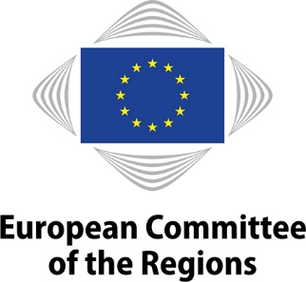
EN
NOTICE OF MEETING

WORKING GROUP "GREEN DEAL GOING LOCAL"

5th meeting
Thursday, 29 April 2021
10 a.m. to 1 p.m. (Brussels time)
Remote meeting: INTERACTIO
Remote link to follow
Interpreting available in: ES, DE, EN, FR, IT, PL.

In light of the current COVID-19 situation, the meeting will be held by video conference only.

Members will receive the link to connect a few days prior to the meeting. All documents for the meeting will be available exclusively on the Members' Portal.

AGENDA

- Opening
- Opening by Juan Espadas Cejas, chair of the working group Green Deal Going Local

- CoR communication campaign on the European Green Deal

- Green Deal debates in regions, cities and villages - the case of Poland and the next steps

- Promoting the Green Deal from the Union to the global stage
- Green Deal in the EU – discussion on delivering the SDGs by 2030

- Green Deal in the EU neighbourhood – discussion on the renewed partnership with the Southern Neighbourhood

- Green Deal at a global level – discussion on Europe's 2030 climate targets towards COP26

- Any other business

_______________

