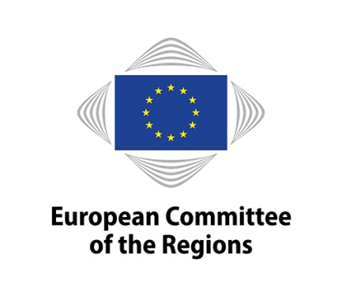
EN

Brussels, 14 November 2017

NOTICE OF MEETING

COMMISSION FOR NATURAL RESOURCES (NAT)

Meeting No | 16
Chair | Ossi MARTIKAINEN (ALDE/FI)
Venue | Committee building, rue Belliard 101, 1040 Brussels (JDE52)
Date | 20/11/2017 11:00-16:30
Amendment deadline | 07/11/2017 15:00 (Brussels time)
Deadline for submitting a delegation of presence | 19/11/2017 at midnight (Brussels time)

10:30-11:00 Meeting of the political coordinators (in camera) (JDE 70)

Draft agenda:

11:00-13:00

Adoption of the draft agenda
COR-2017-04675-00-03-CONVPOJ-TRA

Approval of the minutes of the 15 meeting
COR-2017-04676-00-00-PV-TRA

Statement by the chair

Organisation of future work

For decision:

Opinions on the basis of consultations (Rule 41(a)) - Appointment of rapporteurs

Own-initiative opinions (Rule 41b) i))
- Decision to draw up an opinion
- Appointment of rapporteurs

Own-initiative opinions (Rule 41b) ii))
COR-2017-05077-00-01-TCD-TRA
- Decision to request Bureau authorisation for an opinion
- Provisional appointment of rapporteurs

Decisions not to draw up an opinion

Ongoing work programme and decision on attributions by the president
COR-2017-04677-00-00-TCD-TRA

Work Programme of the NAT commission for 2018
COR-2017-04678-00-00-TCD-TRA

For discussion:

Follow-up to opinions
COR-2017-04679-00-00-TCD-TRA

Opinions - First discussion and adoption

 | Title | Initiative for the sustainable development of the blue economy in the western Mediterranean
 | Rapporteur | Samuel AZZOPARDI (MT/EPP)
 | Commission document | Communication from the Commission to the European Parliament, the Council, the European Economic and Social Committee and the Committee of the Regions Initiative for the sustainable development of the blue economy in the western Mediterranean  COM(2017) 183 final
 | Document | COR-2017-02951-00-00-PA-TRA
 | Type of opinion | Own-initiative (Article 307(4) TFEU)
 | Dossier | NAT-VI/023
 | Statement by | Christos Economou, Head of Unit Sea Basin Strategies, Maritime Regional Cooperation and maritime Security, Directorate-General for Maritime Affairs and Fisheries, European Commission
 | First discussion and adoption | 20/11/2017
 | Adoption planned for the plenary session | 31/01-01/02/2018

State of Play of WHO-CoR Memorandum of Understanding
- Intervention by Leen Meulenbergs, WHO Representative to the European Union

Information on the hurricane disaster in Poland and its consequences
- Intervention of Piotr Całbecki (EPP/PL), President of the Kujawsko-Pomorskie Region

Lunchbreak 13:00-14:30

14:30-16:30

Debate on Consumer Policy with participation of

- Mr Eduard Hulicius, Member of the Cabinet of the Commissioner for Justice, Consumers and Gender Equality
- Mr Nicola Danti, Member of the European Parliament (tbc)Mr Johannes Kleis, Director, The European Consumer Organisation (BEUC)

Mr René Kalfa, Network for the promotion of sustainable consumption in European regions (NEPIM)

Any other business

Confirmation of the date of the next meeting: 22 January 2018 in Brussels

16:30 End of meeting

Working languages: | 23
Interpreting:  (participants may speak in their own language) | 19 | BG/ES/DA/DE/EL/EN/FR/HR/IT/LT/LV/NL/PL/PT/RO/FI/SV/CS/SL
(participants may listen in) | 13 | BG/ES/DA/DE/EN/FR/IT/NL/PL/EL/FI/LV/CS

Amendments must be submitted through the online tool for tabling amendments (available on the Members' Portal at: https://memportal.cor.europa.eu/).

N.B.: Only members of this commission and alternates delegated to attend the meeting will be entitled to travel and subsistence payments.

Members are asked to use the online system for delegation of presence and voting rights in order to confirm their attendance at the meeting or to notify the secretariat of any delegation of presence to another member or alternate under Rule 5(2) of the Rules of Procedure. The online system is accessible through the Members' Portal on the CoR main website.

The Helpdesk (+32-2-546-9697) e-mail: helpdesk@cor.europa.eu will be happy to provide any further assistance you may need.

_____________

