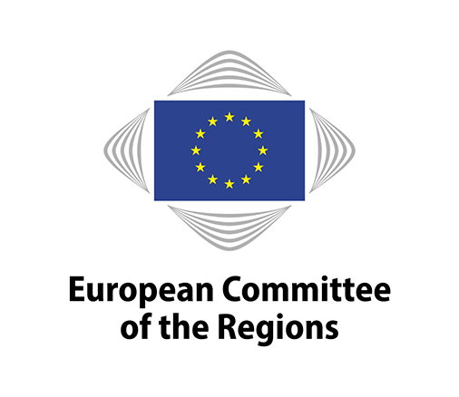
EN

Brussels, 18 January 2018

NOTICE OF MEETING

6th Mandate - Commission NAT

Meeting No | 17
Chair | Ossi MARTIKAINEN (FI/ALDE)
Venue | Committee building, rue Belliard 101, 1040 Brussels (JDE52)
Date | 22/01/2018 11:00 - 18:30
Amendment deadline | 09/01/2018 15:00 (Brussels time)
Deadline for submitting a delegation of presence | 21/01/2018 at midnight (Brussels time)

10:30-11:00 Meeting of the political coordinators (in camera) (JDE 70)

Draft agenda:

11:00-13:00

- Adoption of the draft agenda
COR-2017-05648-00-03-CONVPOJ-TRA

- Debate on the future of health systems with the participation of
- Vytenis ANDRIUKAITIS, Commissioner for Health and Food Safety

- State of Play of WHO-CoR Memorandum of Understanding
- Intervention by Leen MEULENBERGS, WHO Representative to the European Union

- Approval of the minutes of the 16th meeting
COR-2017-05649-00-00-PV-TRA

- Statement by the chair

- Organisation of future work

For decision:

- Opinions on the basis of consultations (Rule 41(a)) - Appointment of rapporteurs

- Own-initiative opinions (Rule 41b) i))
- Decision to draw up an opinion
- Appointment of rapporteurs

- Own-initiative opinions (Rule 41b) ii))
- Decision to request Bureau authorisation for an opinion
- Provisional appointment of rapporteurs

- Decisions not to draw up an opinion
COR-2017-05779-00-00-TCD-TRA

- Ongoing work programme and decision on attributions by the president
COR-2017-05651-00-01-TCD-TRA

- Contribution of the NAT commission to the Annual CoR Impact report
COR-2017-05652-00-01-TCD-TRA

For discussion:

- Follow-up to opinions
COR-2017-05650-00-01-TCD-TRA

- Opinions – Exchange of views

 | Title | Mid-term review of the EU Forest Strategy
 | Rapporteur | Ossi MARTIKAINEN (ALDE/FI)
 | Commission document | N/A
 | Document | COR-2017-5782-00-00-DT-TRA
 | Type of opinion | Own-initiative (Article 307(4) TFEU)
 | Dossier | NAT-VI/027
 | Statement by | Mr Alfonso GUTIÉRREZ TEIRA, DG AGRI, European Commission
 | Adoption | 9/03/2018
 | Adoption planned for the plenary session | 16-17/05/2018

Lunchbreak 13:00-14:30

14:30-18:30

- Opinions - Exchange of views

 | Title | The European Maritime and Fisheries Fund (EMFF) beyond 2020 – Investing in Europe's Coastal Communities
 | Rapporteur | Alberto NÚÑEZ FEIJÓO (EPP/ES)
 | Commission document | N/A
 | Document | COR-2017-5781-00-DT-TRA
 | Type of opinion | Own-initiative (Article 307(4) TFEU)
 | Dossier | NAT-VI/028
 | Statement by | - Mrs Anna ZITO, DG MARE  - Bulgarian Presidency of the Council of the European Union
 | Adoption | 9/03/2018
 | Adoption planned for the plenary session | 16-17/05/2018

- Presentation and debate with members: "The EU-China tourism year 2018"
- Intervention by Anna ATHANASOPOULOU, Head of Unit for Tourism, DG GROW/European Commission
- Intervention by Mr YANG Xiaoguang, Head of the political section, Chinese Mission to the EU
- Debate with members

- Presentation and debate with members: "The European Travel Pass Initiative"
- Intervention by Françoise GUASPERE, Senior advisor of the Île-de-France office in Brussels and Project Leader of the European Travel Pass Initiative at NECSTouR, (Network of European Regions for Competitive and Sustainable Tourism)
- Debate with members

- Presentation and debate with members "Agroforestry"
- Intervention by Olivier BAUDRY, Association for Agroforestry in Wallonia
- Debate with members

- Any other business

- Confirmation of the date of the next meeting: 9 March 2018 in Brussels

End of meeting

Working languages: | 23
Interpreting:  (participants may speak in their own language) | 18 | BG/ES/CS/DA/DE/ET/EL/EN/FR/HR/IT/LV/LT/HU/NL/PL/RO/SK/FI/
(participants may listen in) | 13 | ES/DA/DE/ET/EN/FR/HR/IT/LT/HU/NL/PL/FI

Amendments must be submitted through the online tool for tabling amendments (available on the Members' Portal at: https://memportal.cor.europa.eu/).

N.B.: Only members of this commission and alternates delegated to attend the meeting will be entitled to travel and subsistence payments.

Members are asked to use the online system for delegation of presence and voting rights in order to confirm their attendance at the meeting or to notify the secretariat of any delegation of presence to another member or alternate under Rule 5(2) of the Rules of Procedure. The online system is accessible through the Members' Portal on the CoR main website.

The Helpdesk (+32-2-546-9697; email: helpdesk@cor.europa.eu) will be happy to provide any further assistance you may need.

_____________

