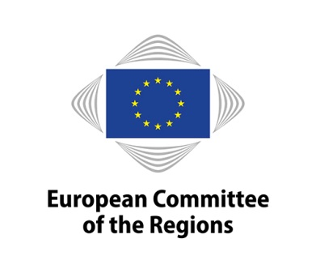 |  | 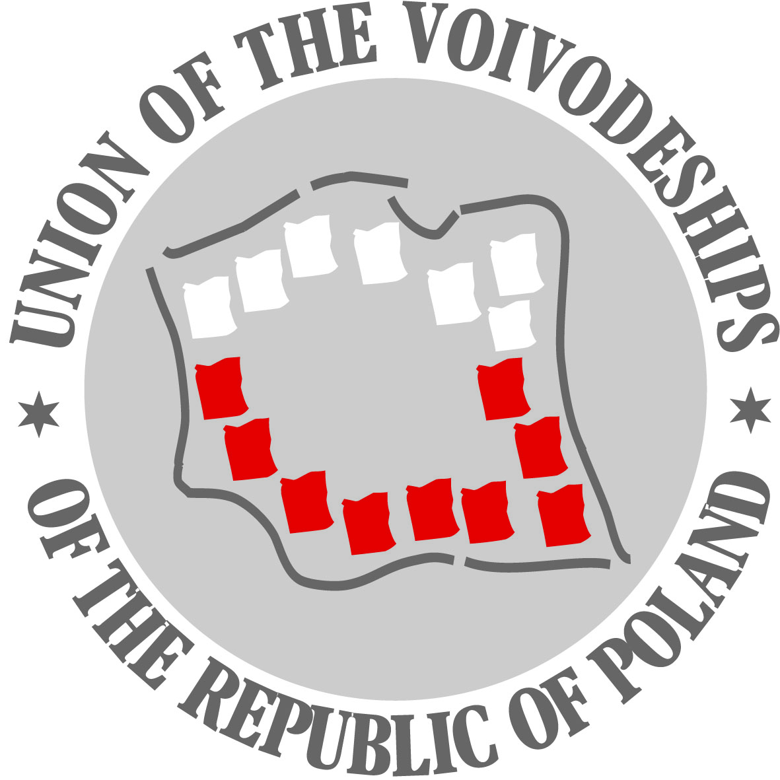

Briefing on the future of Cohesion Policy beyond 2020

9 October 2017, 11.15 – 12.15

at the European Committee of the Regions
room JDE 62
Rue Belliard 99-101

Cohesion policy is the main European investment policy to achieve the EU Treaty objective of economic, social and territorial cohesion. In doing so, cohesion policy has a clear added value in creating jobs, sustainable growth and modern infrastructure, overcoming structural barriers, boosting human capital and improving the quality of life for all citizens across the EU.

Within the context of the ongoing debate on the future of cohesion policy beyond 2020, numerous important actors have already expressed their view on this important matter. The position of Poland on cohesion policy post 2020 was recently adopted by the Polish Committee for European Affairs on 17 July 2017, whilst the 16 Polish regions already agreed on their common position on 23 November 2016. The European Committee of the Regions took its position with the adoption of its opinion on "The future of Cohesion Policy beyond 2020" on 11 May 2017, which was prepared by rapporteur Michael Schneider, State Secretary and Representative of the Land of Saxony-Anhalt to the Federal Government.

Shortly before the opening of the European Week of Regions and Cities, this briefing session will provide an opportunity to present the positions of the Polish Government, the Polish regions and the European Committee of the Regions and to discuss them with an interested audience in Brussels. This forms part of the activities of the European Committee of the Regions promoting the #CohesionAlliance for a strong, effective and more visible cohesion policy beyond 2020.

Draft Agenda:

Introduction by Petr Osvald, Chair of the CoR COTER commission

- "The position of Poland on cohesion policy post 2020",
Jerzy Kwieciński, First Deputy Minister for Economic Development of the Republic of Poland

- "The position of Polish regions on EU cohesion policy beyond 2020",
Olgierd Geblewicz, President of Westpomerania Region

- "The views of the European Committee of the Regions on the future of cohesion policy",
Dr. Michael Schneider, CoR rapporteur on "The future of Cohesion Policy beyond 2020"

- Discussion with the Participants

Interpretation will be provided in Polish, German and English.

