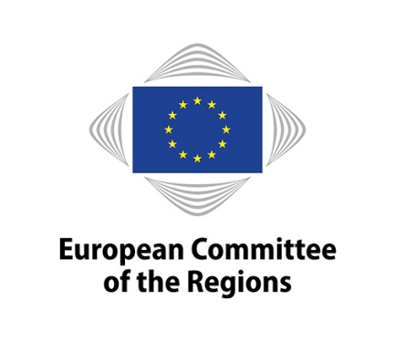 | ENVIRONMENT, CLIMATE CHANGE  AND ENERGY (ENVE)

12th MEETING OF COMMISSION FOR THE ENVIRONMENT, CLIMATE CHANGE AND ENERGY
1st FEBRUARY 2017

Draft Version of 19/12/2016 12:00

Timetable: Commission meeting: from 11.00 to 5.00 p.m.

Meeting room: JDE 52

Draft agenda of the Commissions meeting (COR-2016-06642-00-00-CONVPOJ-TRA)

Approval of the minutes of the 11th meeting (COR-2016-06643-00-00-PV-TRA)

Statement by the chair

Organisation of future work

Opinions on the basis of consultations (Rule 41(a))

Own-initiative opinions (Rule 41b) i))

Own-initiative opinions (Rule 41b) ii))

Decisions not to draw-up an opinion

Ongoing work programme (COR-2016-06555-00-00-TCD-TRA)

Follow-up to opinions (COR-2016-06774-00-00-TCD-TRA)

4.7 ENVE contribution to the CoR impact report 2016 (COR-2016-06782-00-00-TRA)

Opinions – Adoption

Opinion - Adoption
Legislative proposals for a new Effort Sharing Decision and on LULUCF
Rapporteur: Juri Gotmans (EE/PES)

COR-2016-05780-00-00-PA-TRA – ENVE-VI/017

Debate – Results of the fitness-check of the Nature Directives and inter-institutional cooperation under the future Action Plan on their improved implementation

Lunch from 13:00 p.m. to 14:30 p.m.

Debate on the Winter package (background notes)

Opinion - Exchange of views
Space Strategy for Europe
Andres JAADLA (EE/ALDE)

COR-2016-06726-00-00-DT-TRA – ENVE-VI/022

Any other business

Confirmation of the date of the next meeting

