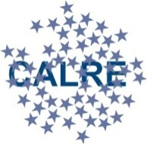
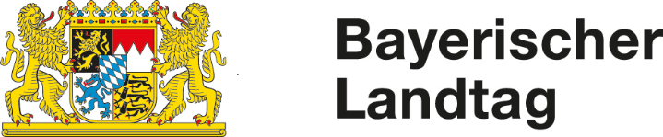

CALRE 2018
Working Group Subsidiarity

agenda

Thursday, March 15th 2018
10:30 – 13:30 h

Committee of the Regions
Rue Belliard 101
1040 Brussels
JDE 51

10:30 h Registration and Welcome Coffee
11.00 h Welcome Address
First Vice President Reinhold Bocklet, MdL, Bavarian State Parliament
11:30 h TOP I - Austrian Presidency of the Council of the European Union Prof. Dr. Klemens H. FISCHER, Minister plenipotentiary and Head of Department at the Permanent Representation of Austria to the EU
12:15 h TOP II - Task Force on Subsidiarity, Proportionality and Doing Less More Efficiently
Guest Speaker: Prof. Dr. Christian CALLIESS
Freie Universität Berlin (on leave), Legal Adviser to the European Political Strategy Center (EPSC) of the President of the European Commission.
13:30 Light Lunch

Interpretation: DE-EN-IT-PT (active/passive) ES (passive)

